**Computer Maintenance and Trouble Shooting (3350701)**

**Teaching Scheme**

|  |  |  |  |  |  |  |  |  |  |  |  |  |  |  |  |
| --- | --- | --- | --- | --- | --- | --- | --- | --- | --- | --- | --- | --- | --- | --- | --- |
|  | **Teaching Scheme** | | | | | **Total** |  | **Examination Scheme** | | |  |  |  | |  |
|  |  | **(In Hours)** | | |  | **Credits** | **Theory Marks** | | **Practical Marks** | | | **Total Marks** |  | |  |
|  |  |  |  |  |  | **(L+T+P)** |  |  |  |  |  |  |  | |  |
|  | **L** |  | **T** |  | **P** | **C** | **ESE** | **PA** | **ESE** | **PA** |  | 150 |  | |  |
|  |  |  |  |  |  |  |  |  |  |  |  |  | |  |
|  | 3 |  | 0 |  | 2 | 5 | 70 | 30 | 20 | 30 |  |  |  | |  |
|  |  | |  |  | |  |  |  |  |  | |  |  | |  |
|  |  | | | | | | | | | | | |  |

**Question Bank**

1. Draw layout of Mother Board.
2. Draw functional block diagram of motherboard and explain its components.
3. What is chipset? Explain Northbridge and Southbridge in detail.
4. Explain BIOS organization.
5. Explain CMOS –RAM.
6. Explain system memory in brief.
7. Explain Computer system.
8. Explain System controller in brief.
9. Explain Memory modules in brief.
10. Difference between PC,PC-XT,PC-AT.
11. Explain types of bus in brief..
12. Difference between CISC vs RISC.
13. Explain logical structure of hard disk drive.
14. Explain RAID interface of Hard Disk.
15. Explain different DVD formats.
16. Compare Blu ray with DVD.
17. Explain SCSI interface of Hard disk.
18. Explain IDE interface of hard disk.
19. Explain wireless keyboard in brief.
20. Explain Key switches in detail.
21. Explain types of mouse in detail.
22. Explain types of scanner in brief.
23. Explain Inkjet printer in brief.
24. Explain Laser Printer in detail.
25. Explain Liquid Crystal Display monitor in brief.
26. Explain LED and plasma display in brief.
27. Explain CRT monitor in brief.
28. Explain thin display in brief.
29. Explain POST in brief.
30. Explain Motherboard troubleshooting in detail.
31. Explain Keyboard troubleshooting in brief.
32. Explain Hard disk drive troubleshooting in brief.
33. Explain Printer troubleshooting.
34. Explain preventive maintenance tools.
35. Explain diagnostic software in brief.
36. Explain hard disk drive performance characteristic.
37. Explain Hard disk controller.
38. Explain DVD recording steps.
39. Explain keyboard interfaces in brief.
40. Explain types of impact printer in detail.

**Answers**

1. **Draw layout of Mother Board.**

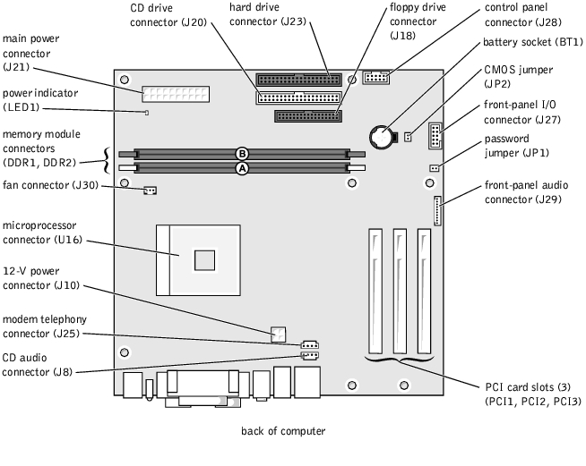

1. **Draw functional block diagram of motherboard and explain its components.**

**Functional block diagram consists of three basic units:**

**EXPANSION SLOTS**

**processor**

**Co-processor**

**ROM**

**BUS SUB SYSTEM**

**DRAM**

**PPI**

**DMA Controller**

**Timer/ Counter**

**Interrupt Controller**

**Clock Generator**

**Fig. 1.3 Functional block diagram of motherboard**

1. Processor

The most important component of a computer is the central processing unit, or CPU, also called the processor. The processor acts as the computer's brain, running programs and sending and receiving signals to attached devices to keep the computer running. Whether you use your computer or mobile device to send email, take pictures, post online or browse the Internet, your processor handles all the data and runs all the programs that enable you to accomplish these tasks.

2. Co-Processor

A coprocessor is a special set of circuit s in a microprocessor chip that is designed to manipulate numbers or perform some other specialized function more quickly than the basic microprocessor circuits could perform the same task. A coprocessor offloads specialized processing operations, thereby reducing the burden on the basic microprocessor circuitry and allowing it to work at optimum speed.

3. Clock Generator

The clock refers to a microchip that regulates the timing and speed of all computer functions. Within this chip is a crystal that vibrates at a specific frequency when electricity is applied. The shortest time any computer is capable of performing is one clock, or one vibration of the clock chip. The speed of a computer processor is measured in clock speed.

4. Bus Sub System:

A computer bus transfers data between components of a computer system. A system bus is a single computer bus for the data transfer between the central processing unit and the memory. The transfer speed of the system bus is a critical element of the overall performance of a computer.

5. Interrupt Controller

An interrupt is a signal from a device attached to a computer or from a program within the computer that causes the main program that operates the computer (the operating system ) to stop and figure out what to do next. There are two types of interrupts.

Maskable interrupt (IRQ): a hardware interrupt that may be ignored by setting a bit in an interrupt mask register's (IMR) bit-mask.

Non-maskable interrupt (NMI): a hardware interrupt that lacks an associated bit-mask, so that it can never be ignored. NMIs are used for the highest priority tasks such as timers, especially watchdog timers.

6. DMA

Computers that have DMA channels can transfer data to and from devices with much less CPU overhead than computers without DMA channels. Similarly, a processing element inside a multi-core processor can transfer data to and from its local memory without occupying its processor time, allowing computation and data transfer to proceed in parallel. DMA can also be used for "memory to memory" copying or moving of data within memory.

**3)What is chipset? Explain Northbridge and Southbridge in detail.**

**Chipset :** In a computer system, a **chipset** is a set of electronic components in an [integrated circuit](https://en.wikipedia.org/wiki/Integrated_circuit) that manages the [data flow](https://en.wikipedia.org/wiki/Data_flow) between the [processor](https://en.wikipedia.org/wiki/Central_processing_unit), [memory](https://en.wikipedia.org/wiki/Computer_memory) and [peripherals](https://en.wikipedia.org/wiki/Peripheral). It is usually found on the [motherboard](https://en.wikipedia.org/wiki/Motherboard). Chipsets are usually designed to work with a specific family of [microprocessors](https://en.wikipedia.org/wiki/Microprocessor). Because it controls communications between the processor and external devices, the chipset plays a crucial role in determining system performance.

**North Bridge:** The Northbridge connects directly to the processor via the front side bus (FSB). A memory controller is located on the Northbridge, which gives the CPU fast access to the memory. The Northbridge also connects to the AGP or PCI Express bus and to the memory itself. A Northbridge or host bridge is a microchip on some PC motherboards and is connected directly to the CPU (unlike the Southbridge) and thus responsible for tasks that require the highest performance. The Northbridge is usually paired with a Southbridge, also known as I/O controller hub

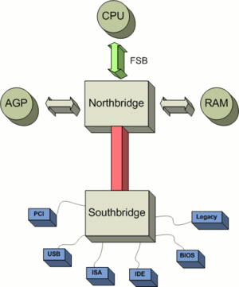

**Fig. 1.4 North Bridge and South Bridge**

**South Bridge:** The Southbridge is slower than the Northbridge, and information from the CPU has to go through the Northbridge before reaching the Southbridge. The Southbridge is one of the two chips in the core logic chipset on a personal computer (PC) motherboard, the other being the Northbridge. The Southbridge typically implements the slower capabilities of the motherboard in Northbridge/Southbridge chipset computer architecture. Other busses connect the Southbridge to the PCI bus, the USB ports and the IDE or SATA hard disk connections. Below is a graphic illustration of the ASUS P5AD2-E motherboard and some basic explanations of each of the major portions of the motherboard including the Southbridge.

**4) Explain BIOS organization.**

The BIOS (Basic Input/output System and also known as the System BIOS, ROM BIOS or PC BIOS) is a type of firmware used during the booting process (power-on startup) on compatible computers.

The BIOS is typically placed in a ROM chip that comes with the computer (it is often called a ROM BIOS). This ensures that the BIOS will always be available and will not be damaged by disk failures. It also makes it possible for a computer to boot itself. Because RAM is faster than ROM, though, many computer manufacturers design systems so that the BIOS is copied from ROM to RAM each time the computer is booted.

**Services**

1. Startup routines

The start-up-routines get the computer going when power is turned on. The main parts of start-up-routines are POST and initialization. POST (Power On Self Test) routines test that the computer is in good working order. The initialization involves routines like creating the interrupt vectors so that when interrupts occur, the computer switches to the proper interrupt-handling routine. Many of the parts of the computer need to have registers set, parameters loaded and other things done to get them in their ready-to-go condition. All these are handled by the initialization routine.

The last part of the start-up-routine. The boot-strap process involves the ROM-BIOS attempting to read a boot record from the beginning of a disk. The BIOS first tries drive A and if that doesn’t succeed it tries to read a boot record from the hard disk if the computer has a hard disk, and then hands over the control of the computer to the short program on the boot record. The boot program begins the process of loading DOS into the computer.

2.Service handling

The service handling routines are there to perform work for the programs. The programs may seek service request to clear the display screen, or to switch the screen from text mode to graphics mode or to read information from the disk or write information onto the printer. To carry out the service requests the ROM-BIOS has to work directly with the computer’s I/O devices.

3.Hardware interrupt handling

The hardware interrupt handling part takes care of the independent needs of the PC hardware. It operates separately, but in co-operation with the service handling portion. When a key is pressed on the keyboard, the keyboard raises an interrupt. The hardware interrupt routines service the interrupt and keep ready the character pressed. When out programs send a request to display the character, the service routine passes the request to the hardware interrupt handling routine. The character is then displayed. ROM BIOS services are organized in groups with each group having its own dedicated interrupt.

1. **Expalin CMOS –RAM.**

CMOS technology is used in microprocessors, microcontrollers, static RAM, and other digital logic circuits. CMOS technology is also used for several analog circuits such as image sensors (CMOS sensor), data converters, and highly integrated transceivers for many types of communication.

Real-Time Clock (RTC), Non-Volatile RAM (NVRAM) or CMOS RAM, CMOS is short for Complementary Metal-Oxide Semiconductor. CMOS is an on-board, battery powered semiconductor chip inside computers that stores information. This information ranges from the system time and date to system hardware settings for your computer. The picture shows an example of the most common CMOS coin cell battery used to power the CMOS memory.

The CMOS is also a computer chip on the motherboard, but more specifically, it is a RAM chip. This is a type of memory chip which stores information about the computer components, as well as settings for those components. However, normal RAM chips lose the information stored in them when power is no longer supplied to them. In order to retain the information in the CMOS chip, a CMOS battery on the motherboard supplies constant power to that CMOS chip. If the battery is removed from the motherboard or runs out of juice (e.g. a dead CMOS battery), the CMOS would lose the information stored in it. Any settings you made in the CMOS setup would be lost, and you would need to make those settings changes again after a new CMOS battery was put on the motherboard. For example, with a dead CMOS battery the time and date will reset back to the manufactured date if it has been off for a long period of time.

1. **Explain System memory in brief.**

In computing, memory refers to the devices used to store information for use in a computer. The term primary memory is used for storage systems which function at high-speed (i.e. RAM), as a distinction from secondary memory, which provides program and data storage that is slow to access but offer higher memory capacity. The term "memory", meaning primary memory is often associated with addressable semiconductor memory, i.e. integrated circuits consisting of silicon-based transistors, used for example as primary memory but also other purposes in computers and other digital electronic devices. There are two main types of semiconductor memory: volatile and non-volatile.

**Volatile memory** is computer memory that requires power to maintain the stored information. Most modern semiconductor volatile memory is either Static RAM or dynamic RAM.

**Non-volatile** memory is computer memory that can retain the stored information even when not powered. Examples of non-volatile memory include read-only memory, flash memory, etc.,

**DIP:** In microelectronics, a dual in-line package (DIP or DIL), or dual in-line pin package (DIPP) is an electronic component package with a rectangular housing and two parallel rows of electrical connecting pins. The package may be through-hole mounted to a printed circuit board or inserted in a socket.

**ZIP:** The zig-zag in-line package or ZIP was a short-lived packaging technology for integrated circuits, particularly dynamic RAM chips. It was intended as a replacement for dual in-line packaging (DIL or DIP). A ZIP is an integrated circuit encapsulated in a slab of plastic with 20 or 40 pins, measuring (for the ZIP-20 package) about 3 mm x 30 mm x 10 mm. The package's pins protrude in two rows from one of the long edges. The two rows are staggered by 1.27 mm (0.05"), giving them a zig-zag appearance, and allowing them to be spaced more closely than a rectangular grid would allow.

**SIPP:** A SIPP (single in-line pin package) or SIP (single in-line package) was a short-lived variant of the 30-pin SIMM random-access memory.

It consisted of a small printed circuit board upon which were mounted a number of memory chips. It had 30 pins along one edge which mated with matching holes in the motherboard of the computer. This type of memory was used in some 80286 and 80386 (80386SX) systems. It was soon replaced by SIMMs using edge connectors, which proved to be more economical and durable. 30-pin SIPP modules were pin compatible with 30-pin SIMM modules explaining why some SIPP modules were in fact SIMM modules with pins soldered onto the connectors.

**SIMM:** A SIMM, or single in-line memory module, is a type of memory module 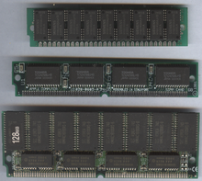containing random-access memory used in computers from the early 1980s to the late 1990s. It differs from a dual in-line memory module (DIMM), the most predominant form of memory module today. The first variant of SIMMs has 30 pins and provides 8 bits of data (plus a 9th error-detection bit in parity SIMMs).

**DIMM:** A DIMM or dual in-line memory module comprises a series of dynamic random-access memory integrated circuits. These modules are mounted on a printed circuit board and designed for use in personal computers, workstations and servers. DIMMs began to replace SIMMs (single in-line memory modules) as the predominant type of memory module as Intel P5-based Pentium processors began to gain market share.

While the contacts on SIMMs on both sides are redundant, DIMMs have separate electrical contacts on each side of the module. Another difference is that standard SIMMs have a 32-bit data path, while standard DIMMs have a 64-bit data path. Since Intel's Pentium, many processors have a 64-bit bus width, requiring SIMMs installed in matched pairs in order to populate the data bus.

**RIMM:** The memory module used with RDRAM chips. It is similar to a DIMM package but uses different pin settings. Rambus trademarked the term RIMM as an entire word. It is the term used for a module using Rambus technology. It is sometimes incorrectly used as an acronym for Rambus Inline Memory Module.

1. **Explain Computer System.**

**Definition**: A computer is a programmable machine that receives input, stores and manipulates data, and provides output in a useful format. Computer is composed of hardware and software, and can exist in a variety of sizes and configurations.

[Hardware](http://www.webopedia.com/TERM/H/hardware.html) consists of wires, transistors, and circuits and instructions and [data](http://www.webopedia.com/TERM/D/data.html) are called [software](http://www.webopedia.com/TERM/S/software.html).

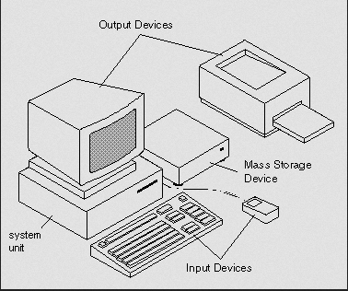

**Fig. 1.1 Computer with its components**

All general-purpose computers require the following components:

* [**Memory**](http://www.webopedia.com/TERM/M/memory.html)**:** enables a computer to [store](http://www.webopedia.com/TERM/S/store.html), at least temporarily, data and programs.
* [**Mass storage**](http://www.webopedia.com/TERM/M/mass_storage.html) [**device**](http://www.webopedia.com/TERM/D/device.html)**:** allows a computer to permanently retain large amounts of data. Common mass storage devices include [disk drives](http://www.webopedia.com/TERM/D/disk_drive.html) and [tape drives](http://www.webopedia.com/TERM/T/tape_drive.html).
* [**Input device**](http://www.webopedia.com/TERM/I/input_device.html)**:** usually a [keyboard](http://www.webopedia.com/TERM/K/keyboard.html) and [mouse](http://www.webopedia.com/TERM/M/mouse.html), the input device is the conduit through which data and instructions enter a computer.
* [**Output device**](http://www.webopedia.com/TERM/O/output_device.html)**:** a [display screen](http://www.webopedia.com/TERM/D/display_screen.html), [printer](http://www.webopedia.com/TERM/P/printer.html), or other device that lets you see what the computer has accomplished.
* **System Unit:** [Central processing unit](http://www.webopedia.com/TERM/C/CPU.html) (CPU) the heart of the computer, this is the component that actually executes instructions.

1. **Explain System controller in brief.**

In computing and especially in computer hardware, a controller is a chip, an expansion card, or a stand-alone device that interfaces with a peripheral device. This may be a link between two parts of a computer (for example a memory controller that manages access to memory for the computer) or a controller on an external device that manages the operation of (and connection with) that device.

In desktop computers the controller may be a plug in board, a single integrated circuit on the motherboard, or an external device. In mainframes the controller is usually either a separate device attached to a channel or integrated into the peripheral.

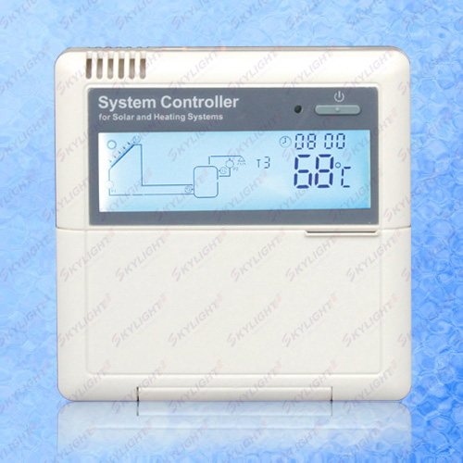

**Fig. 1.4 System Controller**

1. **Explain Memory modules in brief.**

**DRAM**

Dynamic random access memory (DRAM) is the most common kind of main memory in a computer. It is a prevalent memory source in PCs, as well as workstations. Dynamic random access memory is constantly restoring whatever information is being held in memory. It refreshes the data by sending millions of pulses per second to the memory storage cell.

**SRAM**

Static Random Access Memory (SRAM) is the second type of main memory in a computer. It is commonly used as a source of memory in embedded devices. Data held in SRAM does not have to be continually refreshed; information in this main memory remains as a "static image" until it is overwritten or is deleted when the power is switched off. Since SRAM is less dense and more power-efficient when it is not in use; therefore, it is a better choice than DRAM for certain uses like memory caches located in CPUs. Conversely, DRAM's density makes it a better choice for main memory.

**SDRAM**

SDRAM (synchronous DRAM) is a generic name for various kinds of dynamic random access memory (DRAM) that are synchronized with the clock speed that the microprocessor is optimized for. This tends to increase the number of instructions that the processor can perform in a given time. The speed of SDRAM is rated in MHz rather than in nanoseconds (ns). This makes it easier to compare the bus speed and the RAM chip speed. You can convert the RAM clock speed to nanoseconds by dividing the chip speed into 1 billion ns (which is one second). For example, an 83 MHz RAM would be equivalent to 12 ns.

**DDR RAM**

DDR memory, or Double Data Rate memory, is a new high performance type of memory that runs at twice the speed of normal SDRAM. This DDR SDRAM is ideally suited to the latest high performance processors to increase overall system speed.

**DDR2 SDRAM**

DDR2 SDRAM is a double data rate synchronous dynamic random-access memory interface. It superseded the original DDR SDRAM specification, and has since been superseded by DDR3 SDRAM. DDR2 DIMMs are neither forward compatible with DDR3 nor backward compatible with DDR.

**DDR3**

DDR3 SDRAM, an abbreviation for double data rate type three synchronous dynamic random access memory, is a modern type of dynamic random access memory (DRAM) with a high bandwidth ("double data rate") interface, and has been in use since 2007. It is the higher-speed successor to DDR and DDR2 and predecessor to DDR4 synchronous dynamic random access memory (SDRAM) chips. DDR3 SDRAM is neither forward nor backward compatible with any earlier type of random access memory (RAM) due to different signaling voltages, timings, and other factors. DDR3 is a DRAM interface specification. The actual DRAM arrays that store the data are similar to earlier types, with similar performance.

**FPM DRAM**

Fast page mode or FPM memory is slightly faster than conventional DRAM. While standard DRAM requires that a row and column be sent for each access, FPM works by sending the row address just once for many accesses to memory in locations near each other, improving access time. FPM memory itself is an improved version of its predecessor, page mode memory, which is very rarely seen now.

**EDO DRAM**

Extended Data Out Dynamic Random Access Memory, a type of DRAM that is faster than conventional DRAM. Unlike conventional DRAM which can only access one block of data at a time, EDO RAM can start fetching the next block of memory at the same time that it sends the previous block to the CPU.

1. **Difference between PC, PC-XT, PC-AT.**

The success of the IBM computer led other companies to develop IBM Compatibles, which in turn led to brandings like diskettes being in IBM format, or systems complaining about no ROM-BASIC on booting. In essence, during the bulk of the 1980s and early 1990s, the main machines that were talked about in the press and in how-to guides, were IBM ones.

|  |  |  |  |  |
| --- | --- | --- | --- | --- |
| **Model**  **Name** | **Model** | **Introduced** | **CPU** | **Features** |
| PC | 5150 | August 1981 | 8088 | Floppy disk or cassette system |
| XT | 5160 | March 1983 | 8088 | First IBM PC to come with an internal hard drive as standard. |
| AT | 5170 | August 1984 | 80286 | Medium-speed hard disk |

1. **Explain types of bus in brief.**

An **expansion bus** is an assortment of wires that allows for computer expansion with the use of an expansion board, a printed circuit board inserted into an expansion slot on the motherboard or backplane that provides additional features to a computer system.   
An expansion bus provides an input/output pathway for transferring information between internal hardware, such as RAM or the CPU, and expansion devices such as a graphics card or sound card.

A bus is the path through which a device sends its data so that it can communicate with the CPU and/or other devices. For example, a PCI device, such as an audio card, will send its data through the PCI bus. Each device will have an access point to the bus using a particular kind of interface.

1. Front Side Bus: The Front Side Bus is the interface between the CPU and the motherboard, specifically the North Bridge/Memory Controller Hub. See below for details on the FSBs in use by Intel and AMD.

2. Memory busses: The memory bus is the interface between the RAM and the motherboard. Because each variant requires a different type of controller, few motherboards support more than one type of memory. There have been many forms of memory that are now considered obsolete.

3. Control Bus: a signal that is sent by the CPU that coordinates actions of the system.

4. Address Bus: this is where data and instructions are sent from one component to another using the address bus. This is done by using memory location addresses to recognize the location of data in the system memory (RAM).

5. Data Bus: this is the lines or paths for actual data, instructions to be sent to components.

6. Power: this type bus is used to send power to components of the system.

7. PCI Bus: This bus is considered the standard. It can transfer data 64-bit at a time with rates up to 66 MHz.

8. VL-Bus (VESA Local bus): This bus was originally used with the 486 computers and was limited in the number of slots to add on devices. Used for add-in cards such as video display.

9. COMBO Bus. This bus is a combination of of a PCI bus and VL-Bus. It allows the use of both types of add-in cards. This card is recommended since it meets a variety of needs.

**12) Differentiate CISC vs. RISC.**

|  |  |  |
| --- | --- | --- |
| **Aspect** | **RISC** | **CISC** |
| **Acronym** | Reduced Instruction Set Computer | Complex Instruction Set Computer |
| **Instruction set** | Reduced | Complex |
| **Compiler design** | Easy to design | Hard to design |
| **Hardware/Software** | Stresses more on software | Stresses more on hardware |
| **Memory management** | Memory-to-memory operations | Register-to-register operations |
| **Code size** | High in code size | Less in code size |
| **Clocking** | Single clock is used | Multiple clocks are used |
| **Instruction length** | Single word instruction | Variable length instruction |
| **Pipelining** | Pipelining is the major feature | Doesn’t support pipelining |

**13) Explain logical structure of hard disk drive.**

* **Head:** A device called a [head](https://en.wikipedia.org/wiki/Disk_read-and-write_head) reads and writes data in a hard drive by manipulating the magnetic medium that composes the surface of an associated disk platter. Naturally, a platter has 2 sides and thus 2 surfaces on which data can be manipulated; usually there are 2 heads per platter, one per side.
* **Track:** A disk drive track is a circular path on the surface of a disk or diskette on which information is magnetically recorded and from which recorded information is read.

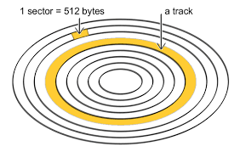

**Fig. Track**

* **Sector:** Each track is divided into arcs called “sectors”.

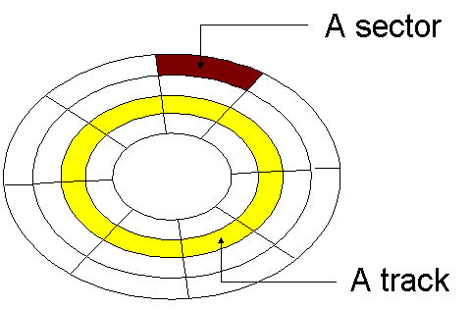

**Fig. Sector**

* **Cylinders:** A Stack of Tracks On top of Each Other is a “Cylinder”.

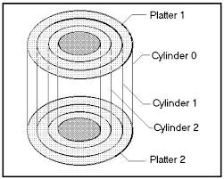

**Fig. Cylinders**

* **Cluster:** is a group of sectors within a disk and is the grouping by which disk files are organized. A cluster is larger than a sector, and most files fill many clusters of disk space.

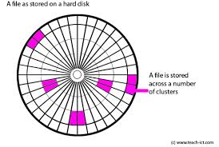

A file is stored across a number of clusters.

* **Landing zone:** A landing zone is an area of the platter usually near its inner diameter (ID), where no data is stored.
* **Master Boot Record (MBR):** Master boot record (MBR) disks use the standard BIOS partition table.
* **Zone bit recording:**Zone Bit Recording (ZBR) is used by [disk drives](https://en.wikipedia.org/wiki/Disk_drives) to store more [sectors](https://en.wikipedia.org/wiki/Disk_sector) per [track](https://en.wikipedia.org/wiki/Cylinder-head-sector) on outer tracks than on inner track. Zones near the edge of disk store more information.

**14) Explain RAID interface of Hard Disk.**

* A RAID array is a logical structure consisting of multiple RAID disks. These disks work together to improve storage reliability and performance.

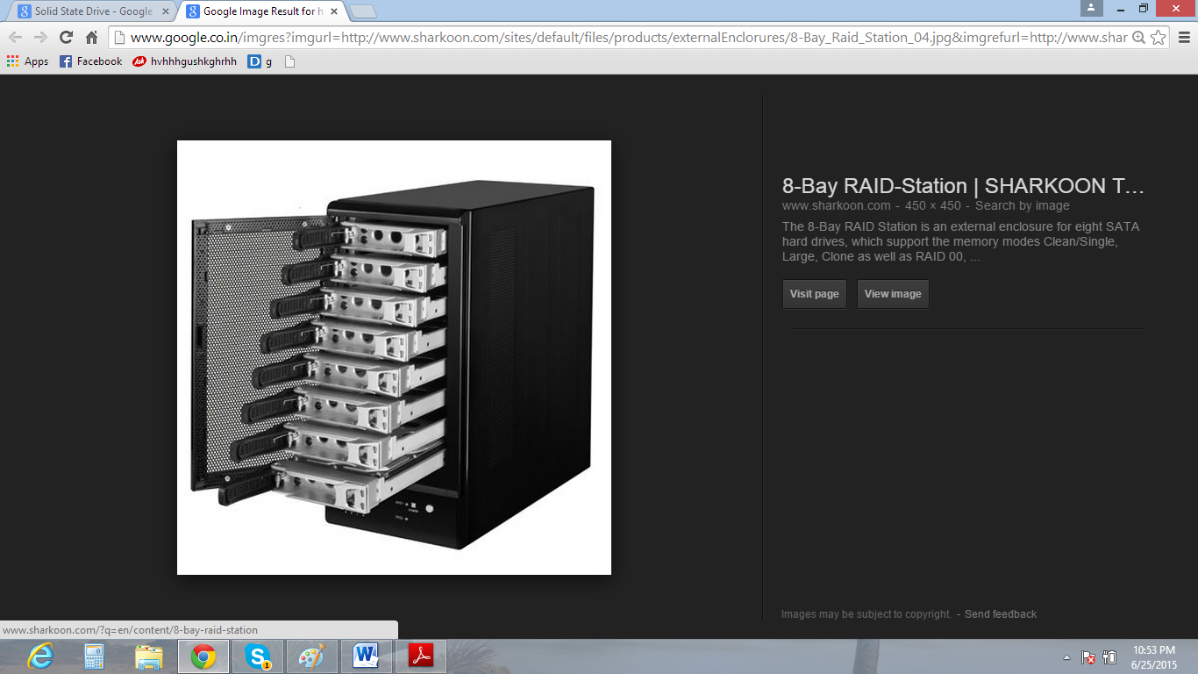

**RAID**

* Originally, the term RAID was defined as redundant array of inexpensive disks, but now it usually refers to a redundant array of independent disks.
* It provides a way of storing the same data in different places (thus, [redundantly](http://searchstorage.techtarget.com/definition/redundant)) on multiple [hard disks](http://searchstorage.techtarget.com/definition/hard-disk) (though not all RAID levels provide [redundancy](http://whatis.techtarget.com/definition/redundancy)). By placing data on multiple disks, input/output ([I/O](http://searchcio-midmarket.techtarget.com/definition/input-output)) operations can overlap in a balanced way, improving performance. Since multiple disks increase the mean time between failures ([MTBF](http://whatis.techtarget.com/definition/MTBF-mean-time-between-failures)), storing data redundantly also increases [fault tolerance](http://searchcio-midmarket.techtarget.com/definition/fault-tolerant).

**RAID Basic Functions**

* It combines multiple hard disks into single logical unit.
* In two way it can be done : in Software and in hardware
* Software does this within the operating system and presents the drives as a single drive to the users of system.
* Hardware combines the drives into logical unit in dedicated hardware which then presents the drives as a single drive to the operating system.
* RAID is typically used on servers but can be used on workstations.

**RAID Level**

* [**RAID 0**](https://en.wikipedia.org/wiki/RAID_0) consists of [striping](https://en.wikipedia.org/wiki/Data_striping), without [mirroring](https://en.wikipedia.org/wiki/Disk_mirroring) or [parity](https://en.wikipedia.org/wiki/Parity_bit). The capacity of a RAID 0 volume is the sum of the capacities of the disks in the set, the same as with a[s panned volume](https://en.wikipedia.org/wiki/Spanned_volume). There is no added redundancy for handling disk failures, just as with a spanned volume. Thus, failure of one disk causes the loss of the entire RAID 0 volumes, with reduced possibilities of [data recovery](https://en.wikipedia.org/wiki/Data_recovery) when compared to a broken spanned volume.
* [**RAID 1**](https://en.wikipedia.org/wiki/RAID_1) consists of data mirroring, without parity or striping. Data is written identically to two (or more) drives, thereby producing a "mirrored set" of drives. Thus, any read request can be serviced by any drive in the set. If a request is broadcast to every drive in the set, it can be serviced by the drive that accesses the data first (depending on its [seek time](https://en.wikipedia.org/wiki/Seek_time) and [rotational latency](https://en.wikipedia.org/wiki/Rotational_latency)), improving performance.
* [**RAID 2**](https://en.wikipedia.org/wiki/RAID_2)consists of bit-level striping with dedicated [Hamming-code](https://en.wikipedia.org/wiki/Hamming_code) parity. All disk spindle rotation is synchronized and data is [striped](https://en.wikipedia.org/wiki/Data_striping) such that each sequential [bit](https://en.wikipedia.org/wiki/Bit) is on a different drive.
* [**RAID 3**](https://en.wikipedia.org/wiki/RAID_3) consists of byte-level striping with dedicated parity. All disk spindle rotation is synchronized and data is striped such that each sequential [byte](https://en.wikipedia.org/wiki/Byte) is on a different drive. Parity is calculated across corresponding bytes and stored on a dedicated parity drive.
* [**RAID 4**](https://en.wikipedia.org/wiki/RAID_4) consists of block-level striping with dedicated parity. This level was previously used by [NetApp](https://en.wikipedia.org/wiki/NetApp), but has now been largely replaced by a proprietary implementation of RAID 4 with two parity disks, called [RAID-DP](https://en.wikipedia.org/wiki/RAID-DP).
* [**RAID 5**](https://en.wikipedia.org/wiki/RAID_5) consists of block-level striping with distributed parity. Unlike in RAID 4, parity information is distributed among the drives. It requires that all drives but one be present to operate. Upon failure of a single drive, subsequent reads can be calculated from the distributed parity such that no data is lost. RAID 5 requires at least three disks.
* [**RAID 6**](https://en.wikipedia.org/wiki/RAID_6) consists of block-level striping with double distributed parity. Double parity provides fault tolerance up to two failed drives. This makes larger RAID groups more practical, especially for high-availability systems, as large-capacity drives take longer to restore. RAID 6 requires a minimum of four disks.

**15) Explain different DVD formats.**

**The Physical Format**

* There are three reasons for DVD's greater data capacity:   
  1.[Smaller pit size](http://www.timefordvd.com/tutorial/pf/DVDTutorial.shtml#PitSize)  
  2.[Tighter track spacing](http://www.timefordvd.com/tutorial/pf/DVDTutorial.shtml#TrackSpacing)  
  3.[Multiple layer capability](http://www.timefordvd.com/tutorial/pf/DVDTutorial.shtml#MultipleLayer)
* **Smaller Pit Size**. DVDs have smaller pit size than CDs.  Pits are the slight depressions or dimples on the surface of the disc that allow the laser pickup to distinguish between the digital 1's and 0's.
* **Tighter Track Spacing**. DVDs also feature tighter track spacing (i.e., track pitch) between the spirals of pits.  In order for a DVD player to read the smaller pit size and tighter track spacing of the DVD format, a different type of laser with a smaller beam of light is required.  (This is one of the major reasons why CD players cannot read DVDs, while DVD players are capable of reading Audio CDs.)

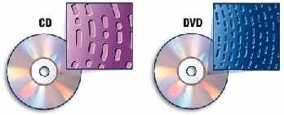

* A comparison of a CD's pit size and track spacing vs. that of a DVD.
* **Multiple Layer Capability**. Finally, DVDs may have up to 4 layers of information, with two layers on each side.  To read information on the second layer (on the same side), the laser focuses deeper into the DVD and reads the pits on the second layer.  When the laser switches from one layer to another layer, it is referred to as the "layer switch" or the "RSDL (reverse spiral dual layer) switch".  To read information from the other side of the DVD, [almost all DVD players](http://www.timefordvd.com/tutorial/pf/DVDTutorial.shtml#FlipSides) require the user to manually flip the disc.
* Based on DVD's dual-layer and double-sided options, there are four disc construction formats:   
  1. [Single-sided, single-layered](http://www.timefordvd.com/tutorial/pf/DVDTutorial.shtml#dvd5)  
  3. [Single-sided, dual-layered](http://www.timefordvd.com/tutorial/pf/DVDTutorial.shtml#dvd9)  
  2. [Double-sided, single-layered](http://www.timefordvd.com/tutorial/pf/DVDTutorial.shtml#dvd10)  
  4. [Double-sided, dual-layered](http://www.timefordvd.com/tutorial/pf/DVDTutorial.shtml#dvd18)
* **Single-Sided, Single-Layered.** Also known as DVD-5, this simplest construction format holds 4.7 Gigabytes (GBytes) of digital data.  The "5" in "DVD-5" signifies the nearly 5 GBytes worth of data capacity.  Compared to 650 Megabytes (MB) of data on CD, the basic DVD-5 has over seven times the data capacity of that of a CD.  That's enough digital information for approximately two hours of digital video and audio for DVD-Video, or 74 minutes of high resolution music for DVD-Audio.
* **Single-Sided, Dual-Layered**. The DVD-9 construction holds about 8.5 GBytes.  DVD-9s do not require manual flipping: the DVD player automatically switches to the second layer in a fraction of a second, by re-focusing the laser pickup on the deeper second layer.  This capability allows for uninterrupted playback of long movies up to four hours!  Frequently, DVD-9 is used to put a movie and its rich set of bonus materials on the same DVD-Video disc, or its optional [DTS Surround Sound](http://www.timefordvd.com/ref/dts.shtml) track.
* **Double-Sided, Single-Layered**. Known as DVD-10, this construction features a capacity of 9.4 GBytes of data.  DVD-10s are commonly used to put a widescreen version of the movie on one side, and a full frame version of the same movie on the other side.  Almost all DVD players require you to manually flip the DVD, that's why the DVD-10 is called the "flipper" disc.  (There are a [few DVD players](http://www.timefordvd.com/tutorial/pf/DVDTutorial.shtml#FlipSides) that can perform the side flipping automatically.)
* **Double-Sided, Dual-Layered**. The DVD-18 construction can hold approximately 17 GBytes (almost 26 times the data capacity of a CD), or about 8 hours of video and audio as a DVD-Video.  Think of DVD-18 as a double-sided DVD-9, where up to four hours of uninterrupted video and audio can be stored on one side.  To access the content on the other side of a DVD-18, you have to manually flip the DVD.  To date, few titles have been released using this construction.  Content providers (e.g., movie studios) usually choose to go with two DVD-9s than a single DVD-18 because DVD-18s cost far more to produce.

**The Application Formats**

* The various application formats of DVD: [DVD-Video](http://www.timefordvd.com/tutorial/pf/DVDTutorial.shtml#DVD-Video), [DVD-Audio](http://www.timefordvd.com/tutorial/pf/DVDTutorial.shtml#DVD-Audio), and [DVD-ROM](http://www.timefordvd.com/tutorial/pf/DVDTutorial.shtml#DVD-ROM).  Each of these three application formats are based on the physical specifications we just discussed.
* **DVD-Video.** The DVD-Video format is by far the most widely known, as it is the first DVD application format to really take off.  As the name indicates, DVD-Video is principally a video and audio format used for movies, music concert videos, and other video-based programming.
* **DVD-Audio**. The DVD-Audio format features high-resolution 2-channel stereo and multi-channel (up to 6 discrete channels of) audio.

**DVD-ROM.** DVD-ROM is a data storage format just like CD-ROM.  DVD-ROMs can only be used in DVD-ROM drives in computer systems.  They allow for data archival and mass storage, as well as interactive and/or web-based content

**16) Compare Blu ray with DVD.**

|  |  |
| --- | --- |
| **Blue-ray** | **DVD** |
| * Storage capacity for single layer is 25 GB and for dual layer 50GB. | * Storage capacity for single layer is 4.7 GB and for dual layer 8.5GB. |
| * It is having blue laser with 405nm wavelength. | * It is having red laser with 650nm wavelength. |
| * Hard coating is available. | * Hard coating is not available. |
| * Data transfer rate is 36.0 Mbps(1x) | * Data transfer rate is 11.08 Mbps(1x) |
| * Data transfer rate for audio and video is 54.0 Mbps(1.5x) | * Data transfer rate for audio and video is 10.08 Mbps(<1x) |
| * Maximum video resolution is 1920 X 1080, | * Maximum video resolution is 720 X 480. |
| * It supports MPEG-2, MPEG-4, and AVC. | * It supports MPEG-2. |
| * It supports following Audio codecs.Dolby digital, Dolby digital plus, Dolby True HD, DTS Digital, DTS-HD | * It supports following Audio codecs.   Dolby digital, DTS Digital, Linear PCM. |

**17) Explain SCSI interface of Hard disk.**

* SCSI (pronounced “scuzzy”) stands for Small Computer System Interface and is a general –purpose interface used for connecting many types of devices to a PC.
* SCSI is the most popular interface for attaching high-speed disk drives to higher performance PCs, such as workstations or network servers. SCSI is also very flexible; it is not only a disk interface, but is also a system-level interface allowing many types of devices to be devices.
* The SCSI controller, called the host adapter, functions as the gateway between the SCSI bus and the PC system bus. Each device on the bus has a controller built in. the SCSI bus does not talk directly with devices such as hard disks; instead, it talks to the controller that is built in to the device.
* Hard disks, tape drives, CD-ROM drives, a graphics scanner, or other peripheral devices attached to a single SCSI host adapter.
* SCSI is a fast interface, generally suited to high performance workstations, servers, or anywhere the ultimate in performance for a storage system interface is needed. The latest Ultra4 (Ultra320) SCSI version supports transfer speeds of up to 320MBPS. An even faster version is being developed called Ultra5.
* The SCSI standards are very specific when it comes to cables and connectors. The most common connectors specified in this are the 50-position unshielded pin header connector for internal SCSI connections and the 50 shielded latch style connector for external connections.

**SCSI Configuration**

* Make sure you are using latest BIOS from your motherboard manufacturer
* Make sure all SCSI devices attached to the bus are powered on.
* Make sure all SCSI cables and power cables are connected properly.
* Make sure SCSI bus terminated and enabled properly at the start and end device.

**SCSI versus ATA (IDE)**

* Fast data transfer rate
* Better performance characteristics
* Good reliability for data and maintenance
* More devices interface on single adapter.
* Supports more powerful operating systems
* Simple construction
* SCSI offer significant architectural advantage
* Store the commands in queue and perform the commands simultaneously with other drives in the system.
* Supports overlapped, multitasked I/O, which enables a device to take on multiple commands and work on them independently.

**18) Explain USB AND IEEE1394 interface of hard disk.**

**USB:**Universal Serial Bus.

* It defines the cables, connectors and[communications protocols](https://en.wikipedia.org/wiki/Communications_protocol) used in a [bus](https://en.wikipedia.org/wiki/Bus_(computing)) for connection, communication, and power supply between [computers](https://en.wikipedia.org/wiki/Computer) and electronic devices.
* USB was designed to standardize the connection of computer peripherals to personal computers, both to communicate and to supply electric power.
* The Universal Serial Bus is a network of attachments connected to the host computer. These attachments come in two types known as **Functions** and **Hubs**.
* Functions are the peripherals such as mice, printers, etc.
* Hubs basically act like a double adapter does on a power-point, converting one socket, called a port, into multiple ports. Hubs and functions are collectively called devices.

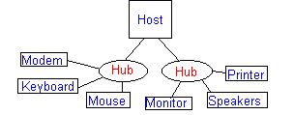

* Above diagram shows the structure of physical USB arrangement
* When the software requires data transfer to occur between it and the USB, it sends a block of data called an **I/O Request Packet** *(IRP)* to the appropriate pipe, and the software is later notified when this request is completed successfully or terminated by error. Other than the presence of an IRP request, the pipe has no interaction with the USB.
* In the event of an error after three retry attempts, the IRP is cancelled and all further and outstanding IRPs to that pipe are ignored until the software responds to the error signal that is generated by sending an appropriate call to the USB.



# Adata transaction is simply a movement of data between the host and a connected device.

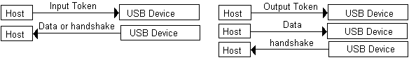

# IEEE 1394 (Fire-wire):-

* IEEE 1394 is an interface standard for a serial bus for high-speed communications and isochronous real-time data transfer. It was developed in the late 1980s and early 1990s by Apple, who called it FireWire.
* FireWire, originally created by Apple and later standardized as IEEE-1394, actually preceded USB and had similar goals.

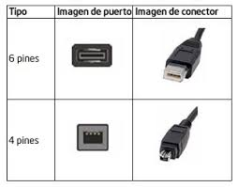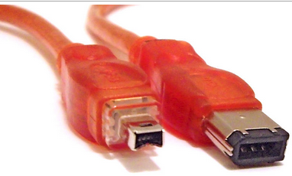

* The 6-conductor connector is commonly found on desktop computers, and can supply the connected device with power.
* 4-conductor alpha connector is widely in use on consumer devices such as camcorders, most PC laptops, a number of PC desktops, and other small FireWire devices.
* The 4-conductor connector is fully data-compatible with 6-conductor alpha interfaces but lacks power connectors.

**19) Explain keyboard types in brief**.

There are basic three standards types of keyboard available on basis of technology.

1. XT
2. AT Standard
3. AT Enhanced

**PC-XT Keyboard:**

* It has total 83 keys so it is also called as 83-key keyboard.

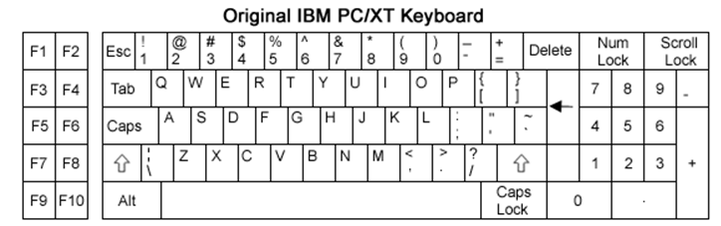

* It has only one side communication. The keyboard can send information/data to the system but the system was not allowed to send any information or command to the keyboard.

**PC-AT Keyboard:**

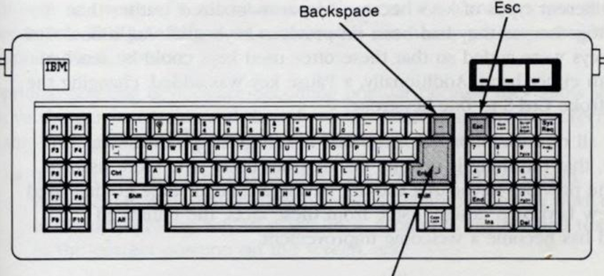

* This keyboard is having 84 keys so it is sometimes referred as 84 keys.
* Numeric keypad is moved away from the letters for easy access during numeric entry.
* Indicator of the three locking shift keys: Num Lock, Scroll Lock, Caps Lock.
* And the size of Enter key is increased.
* The PC-AT keyboard was made programmable. The system can send command and program the keyboard.
* Connectors are same as PC-XT but they are not working interchangeable.

**Enhanced PC-AT Keyboard:**

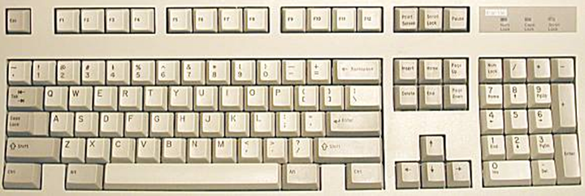

* This keyboard is having total 101 keys and referred as 101 keys keyboard.
* F11 and F12 and other function keys are moved to the top of the keyboard.
* Enter key size is reduced again.
* It provides CTRL and ALT keys on the both side of space bar for easy use.

**20) Explain Key switches in detail.**

1. Pure mechanical
2. Rubber dome
3. Membrane
4. Capacitive

**Pure Mechanical Switches**

* 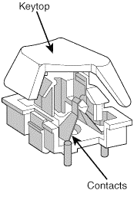The pure mechanical type is just theta simple mechanical switch that features metal contacts in a momentary contact arrangement.
* The switch often includes a tactile feedback mechanism, consisting of a clip and spring arrangement designed to give a "click" feel to the keyboard and offer some resistance to the key press.
* Mechanical switches are very durable, usually have self-cleaning contacts, and are normally rated for 20 million keystrokes (which is second only to the capacitive switch in longevity). They also offer excellent tactile feedback.
* Despite the tactile feedback and durability provided by mechanical key switch keyboards, they have become much less popular than membrane keyboards (discussed later in this chapter).
* In addition, many companies that produce keyboards that use mechanical key switches either use them for only a few of their high-priced models or have phased out their mechanical key switch models entirely.
* With the price of keyboards nose-diving along with other traditional devices, such as mice and drives, the pressure on keyboard makers to cut costs has led many of them to abandon or de-emphasize mechanical-key switch designs in favor of the less expensive membrane key switch.

**Rubber Dome Switches**

* Rubber dome switches are mechanical switches similar to the foam element type but are improved in many ways. Instead of a spring, these switches use a rubber dome that has a carbon button contact on the underside. As you press a key, the key plunger presses on the rubber dome, causing it to resist and then collapse all at once, much like the top of oil can. As the rubber dome collapses, the user feels the tactile feedback, and the carbon button makes contact between the circuit board traces below. When the key is released, the rubber dome re-forms and pushes the key back up.
* The rubber eliminates the need for a spring and provides a reasonable amount of tactile feedback without any special clips or other parts. Rubber dome switches use a carbon button because it resists corrosion and has a self-cleaning action on the metal contacts below. The rubber domes themselves are formed into a sheet that completely protects the contacts below from dirt, dust, and even minor spills.
* This type of switch design is the simplest, and it uses the fewest parts. This made the rubber dome key switch very reliable for several years. However, its relatively poor tactile feedback has led most keyboard manufacturers to switch to the membrane switch design covered in the next section.

**Membrane Switches**

* The membrane key switch is a variation on the rubber dome type, using a flat, flexible circuit board to receive input and transmit it to the keyboard microcontroller.
* Industrial versions of membrane boards use a single sheet for keys that sits on the rubber dome sheet for protection against harsh environments. This arrangement severely limits key travel. For this reason, flat-surface membrane keyboards are not considered usable for normal touch typing.
* However, they are ideal for use in extremely harsh environments. Because the sheets can be bonded together and sealed from the elements, membrane keyboards can be used in situations in which no other type could survive.
* Many industrial applications use membrane keyboards for terminals that do not require extensive data entry but are used instead to operate equipment, such as cash registers and point-of-sale terminals in restaurants.
* Membrane key switches are no longer relegated to fast food or industrial uses, though. Over the last few years, the membrane key switch used with conventional keyboard key tops has replaced the rubber dome key switch to become the most popular key switch used in low-cost to mid-range keyboards.
* Inexpensive to make, membrane switches have become the overwhelming favorite of low-cost Pacific Rim OEM suppliers and are found in most of the keyboards you'll see at your local computer store or find inside the box of your next complete PC. Although low-end membrane key switches have a limited life of only 510 million keystrokes, some of the better models are rated to handle up to 20 million keystrokes, putting them in the range of pure mechanical switches for durability.

**Capacitive Switches**

* Capacitive switches are technically the only truly non-mechanical key switches in use today. Although the movement of the key and spring is mechanical in nature, these components do not close a mechanical contact or switch.
* Capacitive switches are much more expensive than the more common rubber dome mechanical membrane switch, but it is more resistant to dirt and corrosion and offers the highest-quality tactile feedback of any type of switch. Consequently, these are the proverbial Cadillac of keyswitches. This type of keyboard is sometimes referred to as a buckling spring keyboard because of the coiled spring and rocker used to provide feedback.
* A capacitive switch does not work by making contact between conductors. Instead, two plates usually made of plastic are connected in a switch matrix designed to detect changes in the capacitance of the circuit.
* When the key is pressed, the plunger moves the top plate in relation to the fixed bottom plate. Typically, a buckling spring mechanism provides for a distinct over-center tactile feedback with a resounding "click." As the top plate moves, the capacitance between the two plates changes. The comparator circuitry in the keyboard detects this change.
* Because this type of switch does not rely on metal contacts, it is nearly immune to corrosion and dirt. These switches are also very resistant to the key bounce problems that result in multiple characters appearing from a single strike. In addition, they are the most durable in the industry rated for 25 million or more keystrokes, as opposed to 1020 million for other designs. The tactile feedback is unsurpassed because the switch provides a relatively loud click and a strong over-center feel. The only drawback to the design is the cost. Capacitive switch keyboards are among the most expensive designs. The quality of the feel and their durability make them worth the price, however.

**21) Explain types of mouse in detail.**

**Mechanical Mouse:**

A mechanical mouse is a computer mouse that contains a metal or rubber ball on it’s under side. When the ball is rolled in any direction, sensors inside the mouse detect this motion and move the on-screen mouse pointer in the same direction. The picture is an example of the bottom of a mechanical mouse with the ball removed. Now days, this mouse has been replaced by the optical mouse

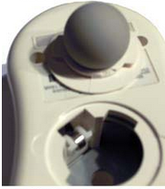

**Mechanical Mouse**

**Opto-Mechanical Mouse:**

* The optical-mechanical or Opto mechanical mouse consists of a ball that rolls one of two wheels inside the mouse.
* Each wheel contains a circle of holes or notches, which allow a [LED](http://www.computerhope.com/jargon/l/led.htm) light to be shined through and detected by a sensor, as the wheel spins they represent an X or Y [axis](http://www.computerhope.com/jargon/a/axis.htm) for the mouse pointer on your screen.
* This mouse is much more accurate than a mechanical mouse that used only wheels and rollers, however, is not as good as an [optical mouse](http://www.computerhope.com/jargon/o/optimous.htm).

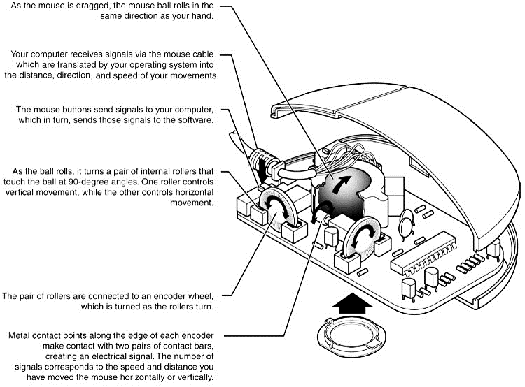

**Opto Mechanical Mouse**

**Optical Mouse:**

* Optical mouse is a computer pointing device that uses a light-emitting diode (LED), optoelectronic sensor and digital signal processor (DSP) to detect changes in reflected light from image to image.
* Optical mice to a more advanced CCD (charge coupled device). This essentially is a crude version of a video camera sensor that detects movement by seeing the surface move under the mouse. An LED or diode laser is used to provide light for the sensor.

Versatility and low maintenance make optical mice an attractive choice, and the variety of models available from both vendors means you can have the latest optical technology for about the price of a good ball-type mouse.All optical mice have a resolution of at least 400dpi and at least one sensor. However, for better performance, some optical mice have improved on these basic features, as listed below.

|  |  |  |
| --- | --- | --- |
| Feature | Benefit | Sample Product |
| 800dpi optical resolution | Improves accuracy for mouse positioning | Logitech MX series, Microsoft IntelliMouse Explorer and Optical series |
| Larger sensor size | Improves tracking on surfaces with repetitive patterns, such as wood desktops | Logitech MX series |
| Faster tracking speed | Able to keep up with fast hand movements, such as when playing games | Microsoft IntelliMouse Explorer and Optical series |
| Dual sensors | Faster speed and accuracy, especially for gaming | Logitech MouseMan Dual Optical |

**22) Explain types of scanner in brief.**

* A scanner is a hardware appliance, connected to a computer that allows the user to take original images and convert them into digital files. Scanners are able to do this by measuring the reflected or transmitted light from the images and record the information into a digital file.

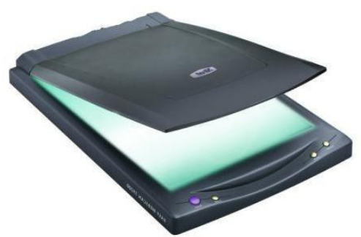

**Scanner**

* There are three types of scanners:

1. Drum scanner

2. Flat-bed scanner

3. Handheld scanner

* A **drum scanner** is an optical input device that mounts original images on a revolving cylinder for scanning.
* Any scanner that incorporates a flat transparent plate, on which original images are placed for scanning, is a **flat-bed scanner**. The scanning process is linear rather than rotational.
* A **hand-held** scanner is a portable, low-cost scanner which is plugged directly into the computer’s printer port, as opposed to the SCSI port. To scan a document, the scanner is scrolled over the document by hand.
* A scanner can be split into two parts: the hardware device that includes the scanner head and motion system, and software that performs the algorithms. The flowing description relates to flatbed scanners.
* When scanning, the first step is placing the hardcopy image that is going to be used on the scanner’s glass pane. The scanning process begins by using the proper scanning software. When the hardcopy is scanned, the signal reflected from the surface “bounces” off mirrors and sent through a collection of red, green and blue (RGB) filters.
* When the signal passes through the filters, red, green, and blue CCD sensors (can also be CMOS or CIS) capture the exposures and record the voltages. Once the pattern of horizontal scanning lines is recorded, two of the colors (ex. red and green) are “buffered until all three colors of individual raster lines are captured".
* The recorded voltages are amplified and converted into digital values by the analog/digital converter.

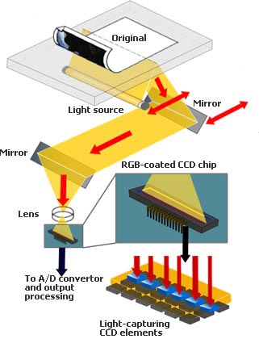

* The scanner head is powered by a motion system that captures the hardcopy line by line from top to bottom. To create the final scanned image, software algorithms, like color transformation and white balancing, are used by using the captured digital RGB values.

**23) Explain Inkjet printer in brief.**

Inkjet printers shoot miniscule droplets of ink onto paper to create a seemingly fluid stroke. No matter where you are reading this article, you most likely have a printer nearby. And there's a very good chance that it is an **inkjet printer**. Since their introduction in the latter half of the 1980s, inkjet printers have grown in popularity and performance while dropping significantly in price. An **inkjet** printer is any printer that places extremely small droplets of ink onto paper to create an image. If you ever look at a piece of paper that has come out of an inkjet printer, you know that:

* The dots are extremely small (usually between 50 and 60 microns in diameter), so small that they are tinier than the diameter of a human hair (70 microns)!
* The dots are positioned very precisely, with resolutions of up to 1440x720 dots per inch (dpi).
* 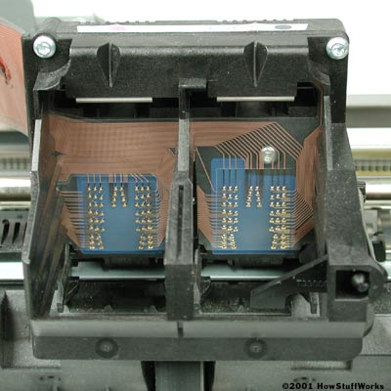The dots can have different colors combined together to create photo-quality images.

1. **Print head assembly**
   * **Print head** - The core of an inkjet printer, the print head contains a series of nozzles that are used to spray drops of ink.

* **Ink cartridges** - Depending on the manufacturer and model of the printer, ink cartridges come in various combinations, such as separate black and color cartridges, color and black in a single cartridge or even a cartridge for each ink color. The cartridges ofsome inkjet printers include the print head itself.
* **Print head stepper motor** - A [stepper motor](http://www.howstuffworks.com/floppy-disk-drive2.htm) moves the print head assembly (print head and ink cartridges) back and forth across the paper. Some printers have another stepper motor to park the print head assembly when the printer is not in use. Parking means that the print head assembly is restricted from accidentally moving, like a [parking brake](http://www.howstuffworks.com/brake.htm) on a car.
* **Belt** - A belt is used to attach the print head assembly to the stepper motor.
* **Stabilizer bar** - The print head assembly uses a stabilizer bar to ensure that movement is precise and controlled

**2. Paper feed assembly**

* **Paper tray/feeder** - Most inkjet printers have a tray that you load the paper into. Some printers dispense with the standard tray for a feeder instead. The feeder typically snaps open at an angle on the back of the printer, allowing you to place paper in it. Feeders generally do not hold as much paper as a traditional paper tray.
* **Rollers** - A set of rollers pull the paper in from the tray or feeder and advance the paper when the print head assembly is ready for another pass.
* **Paper feed stepper motor** - these stepper motor powers the rollers to move the paper in the exact increment needed to ensure a continuous image is printed.

**3. Power supply** - While earlier printers often had an external [transformer](http://www.howstuffworks.com/inside-transformer.htm), most printers sold today use a standard [power supply](http://www.howstuffworks.com/power-supply.htm) that is incorporated into the printer itself.

**4. Control circuitry** - A small but sophisticated amount of circuitry is built into the printer to control all the mechanical aspects of operation, as well as decode the information sent to the printer from the computer.

**5. Interface port(s)** - The [parallel port](http://www.howstuffworks.com/parallel-port.htm) is still used by many printers, but most new printers use the [USB port](http://www.howstuffworks.com/usb.htm). A few printers connect using a [serial port](http://www.howstuffworks.com/serial-port.htm) or small computer system interface ([SCSI](http://www.howstuffworks.com/scsi.htm)) port.

Different types of inkjet printers form their droplets of ink in different ways. There are two main inkjet technologies currently used by printer manufacturers:

|  |  |
| --- | --- |
| **Printer Features:** | **Specifications** |
| Print Technology: | Inkjet or Bubble-jet |
| Print SpeedPPM | 1 - 20 PPM |
| Graphics Resolution | 300 - 1200 DPI |
| Workload (Duty cycle) | 6,000 - 60,000 PPM |
| Price | 3000-5000 Rs |
| Cost Per Page | 0.3-0.5 Rs |

**Thermal bubble** - Used by manufacturers such as [Canon](http://www.howstuffworks.com/framed.htm?parent=inkjet-printer.htm&url=http://www.canon.com) and [Hewlett Packard](http://www.howstuffworks.com/framed.htm?parent=inkjet-printer.htm&url=http://www.hp.com), this method is commonly referred to as bubble jet. In a thermal inkjet printer, tiny resistors create heat, and this heat vaporizes ink to create a bubble. As the bubble expands, some of the ink is pushed out of a nozzle onto the paper. When the bubble "pops" (collapses), a vacuum is created. This pulls more ink into the print head from the cartridge. A typical bubble jet print head has 300 or 600 tiny nozzles, and all of them can fire a droplet Simultaneously.

* **Piezoelectric** - [Patented by Epson](http://www.howstuffworks.com/framed.htm?parent=inkjet-printer.htm&url=http://patft.uspto.gov/netacgi/nph-Parser%3FSect1=PTO1%26Sect2=HITOFF%26d=PALL%26p=1%26u=/netahtml/srchnum.htm%26r=1%26f=G%26l=50%26s1=%275,063,396%27.WKU.%26OS=PN/5,063,396%26RS=PN/5,063,396), this technology uses piezo crystals. A crystal is located at the back of the ink reservoir of each nozzle. The crystal receives a tiny electric charge that causes it to vibrate. When the crystal vibrates inward, it forces a tiny amount of ink out of the nozzle. When it vibrates out, it pulls some more ink into the reservoir to replace the ink sprayed out.

**24) Explain Laser Printer in brief.**

Laser printers as well as LED printers rely on one and the same technology used at first in photocopying machines. This process is known as electrophotography and was invented in 1938 and developed by [Xerox](http://www.xerox.com/) and [Canon](http://www.canon.com/) in the later 1980s.

**Electro-photographic process in laser printers, involves six basic steps:**

A photosensitive surface (photoconductor) is uniformly charged with static electricity by a corona discharge. Then the charged photoconductor is exposed to an optical image through light to discharge it selectively and forms a latent or invisible image.

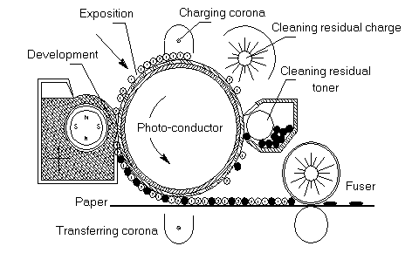

* + 1. Cleaning: The drum is cleaned to remove any trace of the previous page’s data.
    2. Conditioning (Charging): A uniform negative charge is applied to the drum.
    3. Writing: A laser partially neutralizes the negative charge in some areas, painting the entire page image on the drum in static charge.
    4. Developing: The drum rotates past a reservoir of toner with same negative charge as in step1. The toner ignores the areas of the drum with same charge as itself, but sticks to the layered areas with the lesser negative charge.
    5. Transferring: Paper feeds into the printer and receives a positive charge. The toner on the drum jumps off onto the paper because the positive charge of the paper is more attractive than the weak negative charge of the drum.
    6. Fusing: The paper passes through a fuser (a heater) that melts the plastic resin in the toner affixing it to the paper.

Development is done by spreading toner, a fine powder, over the surface, which adheres only to the charged areas, thereby making the latent image visible.

At the next step an electrostatic field transfers the developed image from the photosensitive surface to a sheet of paper. Then the transferred image is fixed permanently to the paper, by fusing the toner with pressure and heat.

The last step is cleaning of all excess toner and electrostatic charges from the photoconductor to make it ready for next cycle.

Laser printers as well as LED printers offer the best print quality i.e. the highest resolution. The unique difference is the method of exposition or formation of the latent image.

**Laser printer scanning assembly:**

Laser printers rely on a laser beam and scanner assembly to form a latent image on the photo-conductor bit by bit. The scanning process is similar to electron beam scanning used in CRT.

The laser beam modulated by electrical signals from the printer's controller is directed through a collimator lens onto a rotating polygon mirror (scanner), which reflects the laser beam.

Then reflected from the scanner laser beam pass through a scanning lens system, which makes a number of corrections to it and scans on the photoconductor.

This technology is the major key for ensuring high precision in laser spot at thefocal plane, accurate dot generation at a uniform pitch and therefore betterprinter's resolution.

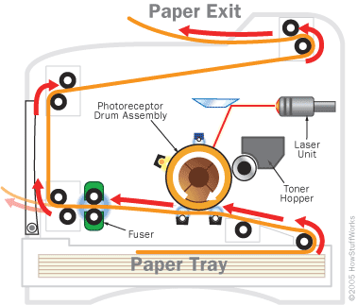

|  |  |  |
| --- | --- | --- |
| **Printer Features:** | **Laser printer Specifications** | **LED printer Specifications** |
| Print Technology: | Electrophotography Laser | Electrophotography LED |
| Print Speed PPM | 4 - 50 PPM | 10 - 26 PPM |
| Graphics Resolution | 300 - 2400 DPI | 300 - 1200 DPI |
| Workload (Duty cycle) | 6,000 - 300,000 PPM | 6,000 - 100,000 PPM |
| Price | 7000-10000 Rs. | 10000-15000 Rs |
| Cost Per Page | 0.5-1Rs | 0.3-1Rs |

**25)Explain Liquid Crystal Display monitor in brief.**

A liquid crystal display (LCD) flat panel display, video display that uses the light modeling properties of liquid crystals. Liquid crystals don’t emit light directly.

* The combination of four facts makes LCDs possible:
* Light can be polarized.
* Liquid crystals can transmit and change polarized light.
* The structure of liquid crystals can be changed by electric current.
* 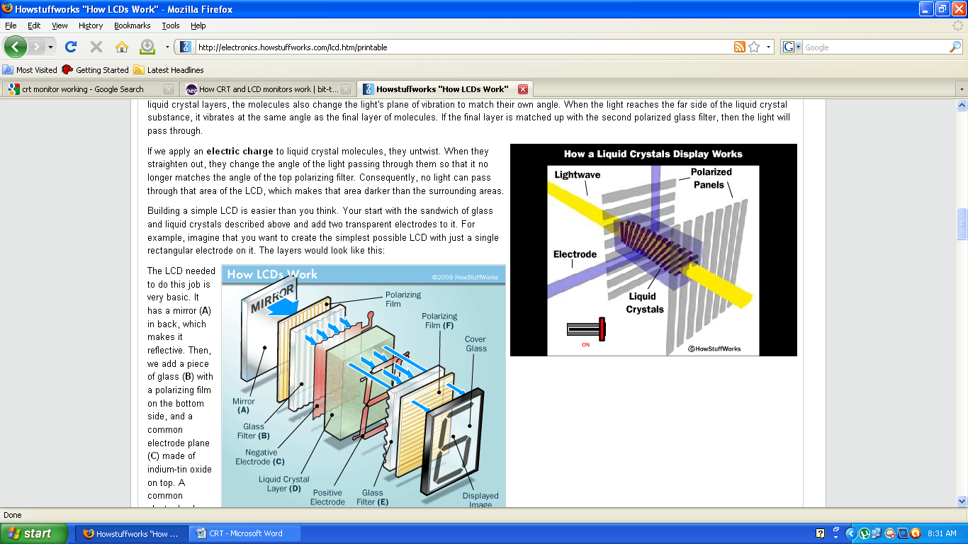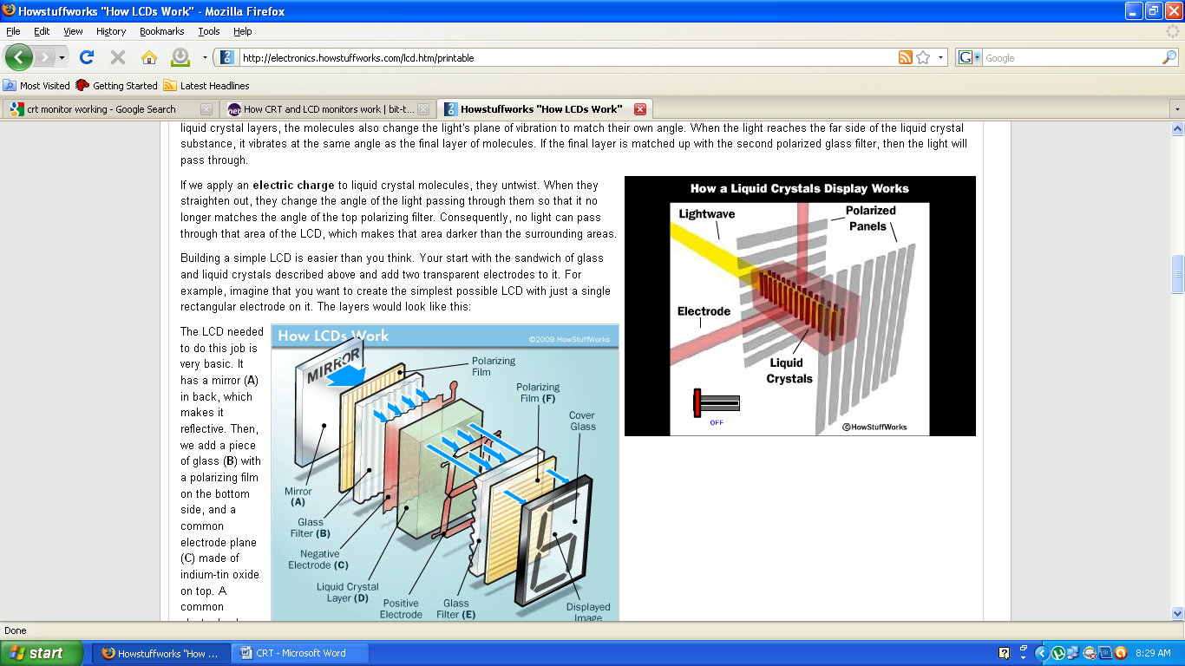There are transparent substances that can conduct [electricity](http://science.howstuffworks.com/electricity.htm).

OFF

ON

* As light strikes the first filter, it is polarized. The molecules in each layer then guide the light they receive to the next layer.
* As the light passes through the liquid crystal layers, the molecules also change the light's plane of vibration to match their own angle. When the light reaches the far side of the liquid crystal substance, it vibrates at the same angle as the final layer of molecules.
* If the final layer is matched up with the second polarized glass filter, then the light will pass through.
* If we apply an **electric charge** to liquid crystal molecules, they untwist. When they straighten out, they change the angle of the light passing through them so that it no longer matches the angle of the top polarizing filter. Consequently, no light can pass through that area of the LCD, which makes that area darker than the surrounding areas.
* 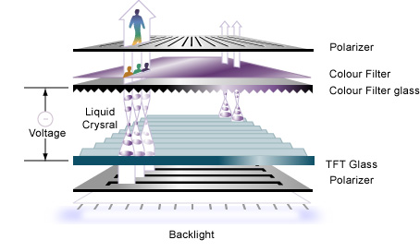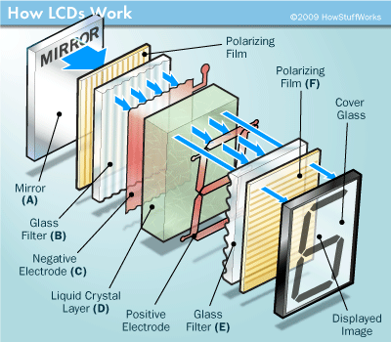The LCD needed to do this job is very basic. It has a mirror (**A**) in back, which makes it reflective. Then, we add a piece of glass (**B**) with a polarizing film on the bottom side, and a common electrode plane (**C**) made of indium-tin oxide on top. A common electrode plane covers the entire area of the LCD. Above that is the layer of liquid crystal substance (**D**). Next comes another piece of glass (**E**) with an electrode in the shape of the rectangle on the bottom and, on top, another polarizing film (**F**), at a right angle to the first one.
* The electrode is hooked up to a power source like a [battery](http://electronics.howstuffworks.com/lcd.htm/battery.htm). When there is no current, light entering through the front of the LCD will simply hit the mirror and bounce right back out. But when the battery supplies current to the electrodes, the liquid crystals between the common-plane electrode and the electrode shaped like a rectangle untwist and block the light in that region from passing through. That makes the LCD show the rectangle as a black area.

**Advantages of LCD Monitors**

* Require less power - Power consumption varies greatly with different technologies.. LCDs also produce less heat.
* Smaller and weigh less - An LCD monitor is significantly thinner and lighter than a CRT monitor, typically weighing less than half as much.
* More adjustable - LCD displays are much more adjustable than CRT displays.
* Less eye strain - Because LCD displays turn each pixel off individually, they do not produce a flicker like CRT displays do. In addition, LCD displays do a better job of displaying text compared with CRT displays.

**26) Explain LED and plasma display in brief.**

**Plasma Display:-**

* A plasma display is a computer video display in which each [pixel](http://searchcio-midmarket.techtarget.com/definition/pixel) on the screen is illuminated by a tiny bit of plasma or charged gas, somewhat like a tiny neon light. Plasma displays are thinner than cathode ray tube ([CRT](http://searchcio-midmarket.techtarget.com/definition/cathode-ray-tube) ) displays and brighter than liquid crystal displays ([LCD](http://searchcio-midmarket.techtarget.com/definition/LCD) ). Plasma displays are sometimes marketed as "thin-panel" displays and can be used to display either[analog](http://searchcio-midmarket.techtarget.com/definition/analog) video signals or [display modes](http://searchcio-midmarket.techtarget.com/definition/display-modes) digital computer input.

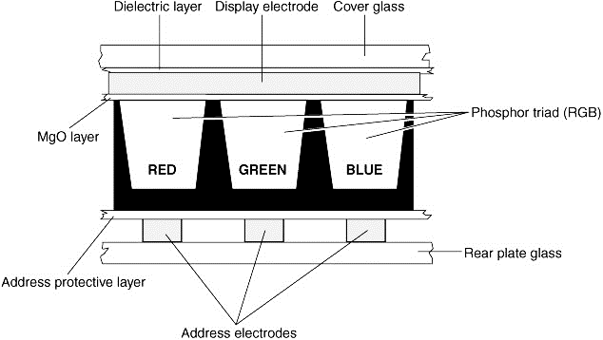

* The display and address electrodes create a grid that enables each sub pixel to be individually addressed. By adjusting the differences in charge between the display and address electrodes for each triad's sub pixels, the signal source controls the picture.
* Display electrode: one scans the frame data; the other is controlled by display driver to apply high voltage to display the image date.
* Address electrode write the column display data into the display cells.

**Advantages of Plasma Display:**

* **Impact:** Plasma displays have more stopping power. Easily seen and noticed.
* **Image:** Spectacular image quality.
* **Flexibility:** Easily changed and updated.
* **Results:** More appealing to watch. Very compelling, sexy and dynamic.

**Applications:**

* Home theater
* Network control room
* Touch screen
* Corporate lobbies
* Video conferencing

**LED: - (Light Emitting Diode)**

* An LED display is a flat panel display, which uses an array of light-emitting diodes as pixels for a video display.
* LED displays are capable of providing general illumination in addition to visual display, as when used for stage lighting or other decorative (as opposed to informational) purposes.
* There are two types of LED : conventional , surface mountain device.
* There are three different types of LED monitors available based on the manner how the diodes are arranges in the monitor. These are – Direct LEDs, Edge LEDs and RGB LEDs.

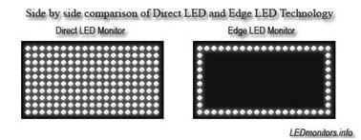

Edge LED

Direct LED

* Both Edge and Direct LED display monitors use white diodes that are used to illuminate the LCD panel to produce the improved picture quality.
* In the Direct LEDs display, white diodes are placed all over the panel to produce higher quality image while the Edge LEDs display uses LEDs only on the borders of the LCD panel.
* Direct LEDs are generally used in the production of high definition TV whereas the Edge LEDs is mainly used in the production of computer screens.
* RGB LEDs display is better among the three types of LED monitors as it uses red, green and blue diodes to produce the lifelike images with amazing contrast ratio

**27) Explain CRT monitor in brief.**

**CRT Monitor – (CRT – Cathode Ray Tube)**

* CRTs receive their picture through an analogue cable, and that signal is decoded by the display controller, which handles the internal components of the monitor.
* Most desktop computer displays make use of CRTs. The CRT in a computer display is similar to the “picture tube" in a television receiver.
* 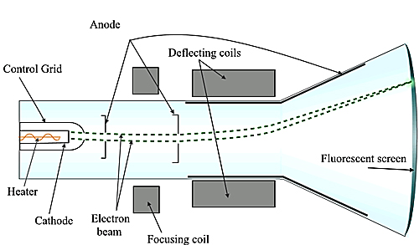CRTs have a distinctive funnel shape. This is shown in the diagram.
* At the very back of a monitor there is an electron gun.
* The electron gun fires electrons towards the front through a vacuum which exists in the tube of the monitor.
* The gun can also be referred to as a cathode - hence the electrons fired forward are called Cathode Rays.
* These rays correspond to the red, green and blue (RGB) channels of the display and video card.
* At the neck of the funnel-shaped monitor is an anode, which is magnetized according to instructions from the display controller.
* As electrons pass the anode, they are shunted or pulled in one direction or the other depending on how magnetic the anode is at that time. This moves the electrons towards the correct part of the screen.
* The electrons pass through a mesh, and this mesh defines the individual pixels and resolution on the screen.
* Electrons that pass through the mesh then hit the phosphor coating which is on the inside of the glass screen.
* When the particles hit the phosphor, they immediately light up - causing the light to shine through the front of the monitor, thus making up the picture on the screen.
* There are three differently colored phosphorus for each pixel (known as phosphor triads), and depending on which phosphor the electron hits, that's which color the pixel will light up.

**Advantages of CRT Monitors:-**

* Less expensive - Although LCD monitor prices have decreased, comparable CRT displays still cost less.
* Better color representation - CRT displays have historically represented colors and different gradations of color more accurately than LCD displays. However, LCD displays are gaining ground in this area, especially with higher-end models that include color-calibration technology.
* More responsive - Historically, CRT monitors have had fewer problems with ghosting and blurring because they redrew the screen image faster than LCD monitors. Again, LCD manufacturers are improving on this with displays that have faster response times than they did in the past.
* Multiple resolutions - If you need to change your display's resolution for different applications, you are better off with a CRT monitor because LCD monitors don't handle multiple resolutions as well.
* More rugged - Although they are bigger and heavier than LCD displays, CRT displays are also less damage and harder to damage

**Disadvantages of CRT Monitors:**

* Brightness limited by tube size
* Resolution (spot size) linked to brightness
* Heavy, bulky displays for small screen sizes

**28)Explain Thin display in brief.**

**Thin Displays:-**

* A transistor whose active, current-carrying layer is a thin film (usually a film of silicon), in contrast to MOSFETs, which are made on Si wafers and use the bulk-silicon as the active layer.
* In a flat-panel display, light must be able to pass through the substrate material to reach the viewer.
* Opaque silicon wafers obviously will not be suitable for theseTrans-missive displays.
* Glass is the most commonly used starting substrate because it is highly transparent and is compatible with conventional semiconductor processing steps.
* Since glass is not a semiconductor like silicon, a thin film of silicon is deposited on top and the transistors are fabricated using this thin layer. Hence, the name "thin-film transistor."

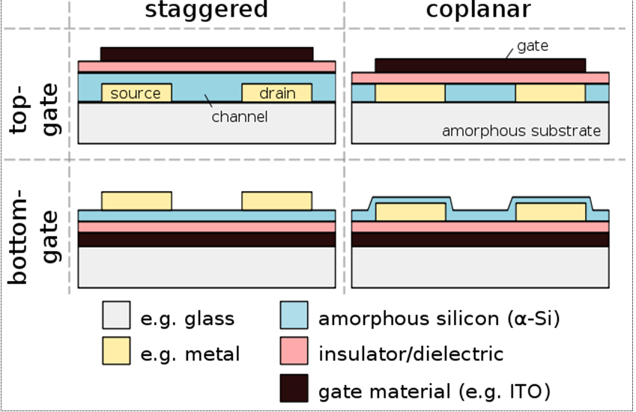

* Flat-panel displays (FPDs) are becoming increasingly commonplace in today's commercial electronic devices.
* FPDs are finding widespread use in many new products, such as cellular phones, personal digital assistants (PDAs), camcorders, and laptop personal computers (PCs).
* This generation of handheld electronics places stringent demands on their displays.
* FPDs in these devices are expected to be lightweight, portable, rugged, low-power and high resolution. Displays having all these attributes will enable a wide variety of commercial applications in the future.
* Active-matrix liquid-crystal displays (AMLCDs) are the leading flat-panel display technology. These displays are ubiquitous in laptops, often dubbed "active-matrix TFT," (an abbreviation for "active-matrix thin-film transistor").
* A display is composed of a grid (or matrix) of picture elements ("pixels"). Thousands or millions of these pixels together create an image on the display. Thin-film transistors (TFTs) act as switches to individually turn each pixel "on" (light) or "off" (dark).

The TFTs are the active elements, arranged in a matrix, on the display. Thus, the name "active-matrix TFT."

**29) Explain POST in brief.**

Stands for "Power On Self Test." POST is a series of system checks run by [computers](http://techterms.com/definition/computer) and other electronic devices when they are turned on.

The results of the test may be displayed on a screen, output through flashing [LEDs](http://techterms.com/definition/led), or simply recorded internally.

The POST operation runs in the beginning of the [boot sequence](http://techterms.com/definition/bootsequence). If all the tests pass, the rest of the startup process continues automatically.

Windows PCs runs a POST every time as and when computer is booted up or restarted.

The BIOS performs a POST when the system is turned on this test is used to ensure that the system contains i.e. CPU clock speed, base memory size, memory size display type etc.

The POST is responsible for the following system and diagnostic functions.

* Performs initial hardware checks, such as determining the amount of memory present
* Verifies that the devices needed to start an operating system, such as a hard disk, are present
* Retrieves system configuration settings from non-volatile memory, which is located on the motherboard

When the problem is identified with the system during the POST, the BIOS will use Beep Code, Error Code and Detail error message methods to represent the problem.

(1) Beep Code: Beeping pattern on the speaker.

(2) Error Code: For every error there is a specific code and that describes the type of error.

(3) Detail Error Message: For every error brief description of error is display on the screen.

**POST beeps codes:**

|  |  |
| --- | --- |
| **Beeps** | **Meaning** |
| 1 short beep | Normal POST – system is OK |
| 2 short beeps | POST error – error code shown on screen |
| 3 long beeps | 3270 keyboard card |
| No beep | Power supply, system board problem, disconnected CPU, or disconnected speaker, |
| Continuous beep | Power supply, system board, or [keyboard](http://en.wikipedia.org/wiki/Computer_keyboard) problem |
| Repeating short beeps | [Power supply](http://en.wikipedia.org/wiki/Power_supply) or system board problem or keyboard |
| 1 long, 1 short beep | [System board](http://en.wikipedia.org/wiki/System_board) problem |
| 1 long, 2 short beeps | [Display adapter](http://en.wikipedia.org/wiki/Display_adapter) problem (MDA, CGA) |
| 1 long, 3 short beeps | [Enhanced Graphics Adapter](http://en.wikipedia.org/wiki/Enhanced_Graphics_Adapter) (EGA) |

POST is part of a devices pre-boot sequence. When POST is successfully finalized, bootstrapping is enabled. Bootstrapping starts the initialization of the OS. Examples of a bootstrapping program are the Linux Loader, Windows NT Loader.

**POST sequence:**

* Processor test
* BIOS ROM TEST
* Timer Test (Programmable interval timer)
* DMA channel 0 test
* CRT test
* Motherboard support chips test
* RAM test
* Peripheral controller test

**30) Explain Motherboard troubleshooting in detail.**

Motherboard failures can be because of following reasons.

* Power failure
* Bus failure
* Component failure

Due to the complexity in the structure and components in computer motherboards, the failure rate is relatively high.

Following table shows the problems, diagnosis and their solutions.

**Indication:**System has no power at all. Fan inside the power supply does not turn. Indicator light on keyboard does not turn on.

|  |  |  |
| --- | --- | --- |
| **Problems Cause** | **Diagnosis** | **Solution** |
| Power cable is unplugged. | Check Power cable | Make sure power cable is securely plugged in. |
| Defective Power cable | Try another cable | Replace another cable |
| Circuit breaker or fuse blown. | Plug device into socket know to work and test. | Use different socket, repair outlet, reset circuit breaker or replace fuse. |

* **Indication:** Systeminoperative. Keyboard lights are on, power indicator lights are lit, and hard drive is spinning.

|  |  |  |
| --- | --- | --- |
| **Problems Cause** | **Diagnosis** | **Solution** |
| Damaged Hard Disk or Disk Controller | Format hard disk; if unable to do so, the hard disk may be defective. | Contact Technical Support |
| Connector between hard drive and system board unplugged. | Invalid drive specification. | Check the drive type in the Standard CMOS Setup (in your motherboard manual) |

* **Indication:** Booting from Hard Disk is impossible.

|  |  |  |
| --- | --- | --- |
| **Problems Cause** | **Diagnosis** | **Solution** |
| Hard Disk boot program has been destroyed | A number of causes could be behind this | Back up data and applications files.  Re-install applications and data using backup disks |

* **Indication:** Screen message displays "Invalid Configuration" or "CMOS Failure."

|  |  |  |
| --- | --- | --- |
| **Problems Cause** | **Diagnosis** | **Solution** |
| Incorrect information entered in setup program. | Replace with correct information. | Review system equipment. |

* **Indication:** Screen is blank

|  |  |  |
| --- | --- | --- |
| **Problems Cause** | **Diagnosis** | **Solution** |
| Monitor not connected to computer. | Power connectors may be loose or not plugged in | Check the power connectors to monitor and to system. Make sure monitor is connected to display card, change I/O address on network card if applicable |

* **Indication:** Missing operating system

|  |  |  |
| --- | --- | --- |
| **Problems Cause** | **Diagnosis** | **Solution** |
| Monitor not connected to computer. | Power connectors may be loose or not plugged in | Check the power connectors to monitor and to system. Make sure monitor is connected to display card, change I/O address on network card if applicable |

**31) Explain Keyboard troubleshooting in brief.**

**Indication: Non operation performed by keyboard**

If a keyboard is not working, it may be because of broken connection between keyboard and main system.

**Solution:**

* Check the connection behind system and make it tight. Also check the cable connecting the key board and main system. If it is OK and the keyboard is still not working then check the compatibility switches behind the keyboard. It is very much possible that you have selected an XT mode for an AT system.
* Most of the system contains keyboard lock on front panel. Check it also it may be locked. If it is so, unlock the keyboard. Though in most of the cases during boot the system informs you that key board is locked.

**Indication: Keystroke reliability or key are misbehaving**

* It is cause of particular key is used frequently.
* Keyboard is having dirt
* Internal mechanism is damaged.

**Solution:**

* Clean keyboard carefully.
* Verify key in other programs
* Change key or keyboard if required.

**Indication: Keyboard error when system is startup**

* It cause of loose keyboard connection
* Key is being pushed down while the computer starts.

**Solution:**

* Don’t startup the PC with key pressed
* Confirm that keyboard is connected properly.

**32) Explain Hard disk drive troubleshooting in detail.**

# Indication: The BIOS does not detect or recognize the hard drive

There are following main reasons why a system BIOS will not detect the presence of an internal hard drive.  Here is a list of them.  [Drive not enabled in the BIOS](http://knowledge.seagate.com/articles/en_US/FAQ/168595en/#1)

* [Serial ATA drivers are not properly installed](http://knowledge.seagate.com/articles/en_US/FAQ/168595en/#2)
* [Faulty or unplugged data cable](http://knowledge.seagate.com/articles/en_US/FAQ/168595en/#3)
* [Drive is not spinning up](http://knowledge.seagate.com/articles/en_US/FAQ/168595en/#4)
* [Incorrect jumper settings on the drive](http://knowledge.seagate.com/articles/en_US/FAQ/168595en/#5)
* [Faulty hard driv](http://knowledge.seagate.com/articles/en_US/FAQ/168595en/#6)e

# Indication:Hard disk makes noise problem

When the system ventilation fans get dirty or out of balance they can begin to make noise.

The level and type of noise may change depending on the function the drive is performing.

**Normal sounds include:**

1. Whining noise during drive spin-up.
2. Regular clicking or tapping sounds during drive access.
3. Hard clicks when the drive heads park during power saving modes like Standby or Hibernation.

* Verify the hard drive source of noise by removing cover of the system and identify source of noise.
* Run diagnostics on hard disk. Replace hard drive if problem is not resolved.
* Back up the data, it may be dead.

# Indication:Cannot detect hard disk after formatting

**Solution**

### Set Hard disk drive mode to IDE if it is set in AHCI ([Advanced Host Controller Interface](https://en.wikipedia.org/wiki/Advanced_Host_Controller_Interface)) and check if this resolves the issue. Locate this setting in BIOS. Set and reboot.

# Indication:Hard Disk becomes very slow

* Software not installed properly
* Hard disk infected by virus or worms

**Solution**

* Check Hard drive with latest virus definition
* Clear temporary files
* If problems are not resolved install or reload the operating system.

**33) Explain Printer troubleshooting in brief.**

## Indication: Printer does not have power indicator

**Solution**

* First, make sure that the printer is on. When a printer is on it should have some light or LED indicating its receiving power.
* If you do not have any indicator light, make sure the printer is connected with power cable.
* After performing above steps printer is still not working repair or replace printer.

## Indication: Cables not connected properly

**Solution**

* Printer should have two cables connected to it: the power cable and the data cable. Make sure the power and data cables ([parallel cable](http://www.computerhope.com/jargon/p/paraport.htm) or [USB](http://www.computerhope.com/jargon/u/usb.htm) cable) are connected to both the printer and computer.

## Indication: No paper or paper jam

**Solution**

* If paper jammed while printing try following
* Turn off the printer, and then unplug cable. Remove rear door and also remove jammed paper, then replace the rear door.
* Open the top door and clear the printer of any paper obstructing the paper path.
* Try pulling out the main tray and replacing it in the printer, making sure to push the try in as far as it will go, until it fully seated.
* Printer may need attention. Read the printer screen for instruction.

## Indication: Margins are printed wrong

**Solution**

* Check margin settings in application.
* Check paper is loaded in correct orientation.

## Indication: Papers are not feed into printer correctly from main try

**Solution**

* Reduces sheets in the try.
* Push main try into printer correctly.
* If the paper is wrinkled or bent try using different paper.
* Paper might be too thin or too thick.

**34) Explain Preventive Maintenance tools.**

**Preventive** - That which tends to stop undesired things from happening

**Maintenance** - support, defense, upkeep

The main goal of any preventive maintenance program is to preempt problems before they happen.

**Hardware Tools:**

Following Hardware tools are use for maintenance.

**Multi meter:-**

|  |
| --- |
| * It is use for measurement of voltage, current and to test continuity of cable. * With help of multi meter power supply can be checked. |

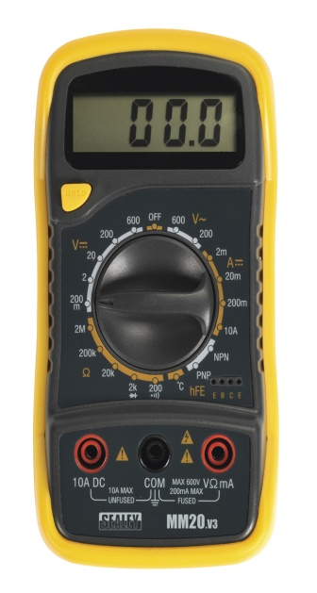

**Logic Analyzer:-**

|  |
| --- |
| * It is also known as multilevel oscilloscope with a memory. * Logic Analyzer display can show individual pulse width and frequency information. * It can have ability to freeze a signal data pattern any time, which gives advantages of troubleshooting. * Logic analyzers can uncover hardware defects that are not identified in simulation process. |

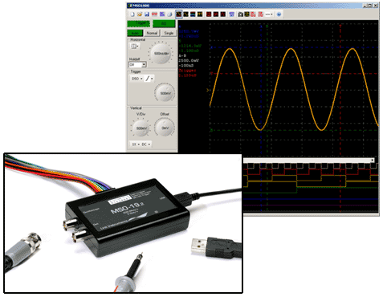

|  |
| --- |
| * It displays logic levels (high or low), pulses & voltage transients. * A logic probe is a hand-held pen-like test probe used for analyzing and  troubleshooting the logical states (Boolean 0 or 1) of a digital circuit. * Using logic probe near by 85% of faults can be diagnosed without an oscilloscope. * Three colored LEDs on the probe: Red and green LED shows high and low states when an amber LED shows a pulse. |
| |  | | --- | | * Handheld troubleshooting tool used to detect current flow in logic circuits. * It is used in shorted components, solder bridge etc. | |  | |

**Logic Probe:-**

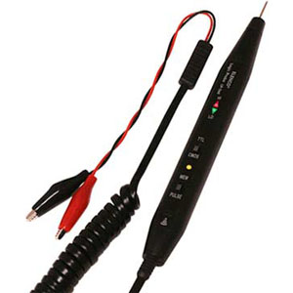

**Current Tracer:-**



**35) Explain Diagnostic software in detail.**

Following software tools are used for maintenance.

Software maintenance tools are programs used by software engineers to increase their productivity for gathering data, detecting bugs and managing their software.

Software maintenance is the general process of changing a system after it has been diverted.

**Dr.Watson :-**

* It is an application debugger included in Windows operating system.
* Idea being that it would collect error information for a [program](https://en.wikipedia.org/wiki/Computer_program) crash.

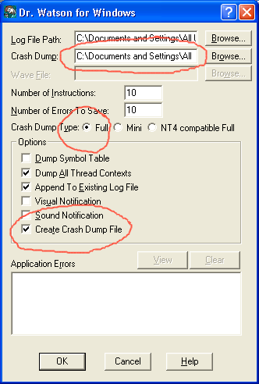

* Dr. Watson is the information needed by technical support personnel to diagnose a program error for a computer running Windows. A text file (usually drwtsn32.log) is created whenever an error is detected.
* When a program error occurs in Windows, the system searches for a program error handler.
* A program error handler deals with errors as they arise during the running of a program. If the system does not able to find a program error handler, the system verifies that the program is not currently being debugged and considers the error to be unhandled.
* The system then processes unhandled errors by looking in the [registry](https://en.wikipedia.org/wiki/Windows_Registry) for a program error debugger for which Dr. Watson is the default.

**Norton Utilities:-**

* It identifies the problems beyond the system information program.
* Norton Utilities is a good program for helping your maintain a fully functioning PC.
* Below are Norton utilities which are used for software maintenance.
  + Duplicate File Finder: Finds duplicate files from the system and remove it.
  + Speed Disk:Brings and recognized the files and data that it scattered across hard drive.
  + Disk Cleaner: Clear all the records of computer and web activities.
  + Registry Cleaner: Helps to remove registry problems that slow down your computer.
  + Startup Manager: Allows you to choose what programs can startup automatically when Windows starts.

**36) Explain hard disk drive performance characteristic.**

* When you select a hard disk drive, one of the important features you should consider is the performance (speed) of the drive. Hard drives can have a wide range of performance capabilities.
* Disk Performance can be grouped into two categories:**access time and transfer time.**

**Access Time:**It is a measure of time it takes before the drive can actually transfer data.

* Factors that control this time on rotating drive are mostly related to mechanical nature of rotating disk and moving heads.
* Key components of access time are:(1) Seek time and (2) Latency

1. **Seek Time:** Seek time, usually measured in milliseconds (ms), is the average amount of time it takes to move the heads from one cylinder to another a random distance away.

* One way to measure this specification is to run many random track-seek operations and then divide the timed results by the number of seek performed. This method provides an average time for a single seek.

1. **Latency:**Latency is the average time (in milliseconds) it takes for a sector to be available after the heads have reached a track.

* It depends on rotational speed of disk measured in revolutions per minute (RPM).
* Latency and access time can be improved by increasing speed of the head. Speed can use one of two types of disk rotation methods.
  + Constant linear velocity (CLV): Mainly used in optical storage, varies the speed of optical disk depending upon the position of the head.
  + Constant angular velocity (CAV): used in HDD, FDD, few optical disk system spins the media at one constant speed regardless of where the head is positioned.

**Data Transfer Time (Throughput):** It is also called throughput.

* It covers both external rate and internal rate.
  + - Internal Rate: Moving data between the disk surface and the controller on the drive.
    - External Rate: Moving data between the controller on the drive and the host system.
* **Media Rate:**Rate at which the drive can read bits from the surface of the media.
* **Sector overhead time:**Additional time (bytes between sectors) needed for control structures and other information necessary to manage the drive
* **Head switch time:**Additional time required to electrically switch from one head to another and begin reading.
* **Cylinder switch time:**Additional time required to move to the first track of the next cylinder and begin reading. This time is typically about twice the track-to-track seek time.

**37)Explain Hard disk controller in brief.**

* A hard disk controller (HDC) is an electrical component within a computer hard disk that enables the processor or CPU to access, read, write, delete and modify data to and from the hard disk. Essentially, an HDC allows the computer or its processor to control the hard disk.

**HDC Functions**

A hard disk controller's primary function is to translate the instructions received from the computer into something that can be understood by the hard disk and vice versa.

* It consists of an expansion board and its related circuitry, which is usually attached directly to the backside of the hard disk.
* The instructions from a computer flow through the hard disk adapter, into the hard disk interface and then onto the HDC, which sends commands to the hard disk for performing that particular operation.
* Typically, the type and functions of a hard disk controller depend on the type of interface being used by the computer to access the hard disk. For example, an IDE hard disk controller is used for IDE interface based hard disks.

**38) Explain DVD Recording steps.**

**Step 1**

* Most computers recently purchased already come with general DVD burning software. Locate the file or files that you want to be copied on a DVD. It is advisable to sort out the files that you want to be copied inside a single folder for easier navigation.

**Step 2**

* Open the DVD burning software on your computer. Open the disc drive and insert the blank DVD. Close the disc drive.

**Step 3**

* Make sure that the files that you are going to burn on the DVD fit the space on the blank DVD.

**Step 4**

* Open the files that you are going to burn. Click on the 'burn' button on the interface of the DVD burning software. The burning of the DVD can take up time, depending on the size of the files that are going to be burned. Wait for the burning of the DVD to be complete.

**Step 5**

* Eject the DVD from the disc drive. Close the disc drive.

**Step 6**

* A computer that runs on Windows XP can also burn DVDs. Click on the 'Start' button. Select 'All Programs' from the menu. Click on 'Accessories' and select 'Windows Explorer' from the submenu.

**Step 7**

* Insert a blank DVD on the disc drive.

**Step 8**

* Locate the files that you want to be burned on the blank DVD. Select these files and drag them on the DVD burner icon on 'Windows Explorer'.

**Step 9**

* Click 'File'. Select 'Write these files to CD' on the menu. A burning wizard will be displayed on the screen. Follow the instructions on the burning wizard. Wait for the wizard to finish burning your DVD.

**Step 10**

* Eject the DVD from the disc drive and close the disc drive.

**39) Explain Keyboard interfaces in brief.**

A keyboard consists of a set of switches mounted in a grid or an array called the key matrix. When a switch is pressed, a processor in the keyboard identifies which key is pressed by determining which grid location in the matrix shows continuity. The keyboard processor, which also interprets how long the key is pressed, can even handle multiple keypresses at the same time. A 16-byte hardware buffer in the keyboard can handle rapid or multiple keypresses, passing each one to the system in succession.

When you press a key, the contact bounces slightly in most cases, meaning that several rapid on/off cycles occur just as the switch makes contact. This is called *bounce*. The processor in the keyboard is designed to filter this, or *debounce* the keystroke. The keyboard processor must distinguish bounce from a double key strike the keyboard operator intends to make. This is fairly easy, though, because the bouncing is much more rapid than a person could simulate by striking a key quickly several times.

The keyboard in a PC is actually a computer itself. It communicates with the main system in one of two ways:

* Through a special serial data link if a standard PS/2 keyboard connector is used
* Through the USB port

The serial data link used by conventional keyboards transmits and receives data in 11-bit packets of information, consisting of 8 data bits, plus framing and control bits. Although it is indeed a serial link (in that the data flows on one wire), the keyboard interface is incompatible with the standard RS-232 serial port commonly used to connect modems.

In the original PC/XT design, the keyboard serial interface is connected to an 8255 Programmable Peripheral Interface (PPI) chip on the motherboard of the PC/XT. This chip is connected to the interrupt controller IRQ1 line, which is used to signal to the system that keyboard data is available. The data is then sent from the 8255 to the processor via I/O port address 60h. The IRQ1 signal causes the main system processor to run a subroutine (INT 9h) that interprets the keyboard scan code data and decides what to do.



**40) Explain types of impact printers in brief.**

**Impact Printer**

* An impact printer makes contact with the paper. It usually forms the print image by pressing an inked ribbon against the paper using a hammer or pins.
* Following are Impact Printers

**Dot Matrix Printer**

* The dot-matrix printer uses print heads containing from 9 to 24 pins. These pins produce patterns of dots on the paper to form the individual characters. The 24 pin dot-matrix printer produces more dots that a 9 pin dot-matrix printer, which results in much better quality and clearer characters.

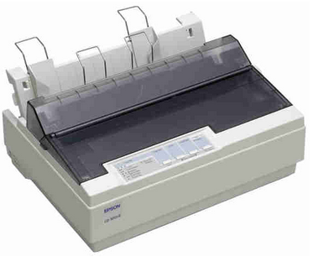

**Dot Matrix Printer**

* The general rule is: the more pins, the clearer the letters on the paper. The pins strike the ribbon individually as the print mechanism moves across the entire print line in both directions, from left to right, then right to left, and so on.
* Dot-matrix printers are inexpensive and typically print at speeds of 100-600 characters per second.

**Daisy-Wheel Printer:-**

* In order to get the quality of type found on typewriters, a daisy-wheel impact printer can be used.
* It is called daisy-wheel printer because the print mechanism looks like a daisy; at the end of each “Petal” is a fully formed character which produces solid-line print.

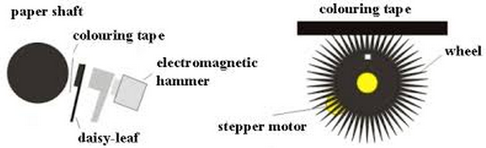

**Daisy-Wheel Printer**

* A hammer strikes a “petal” containing a character against the ribbon, and the character prints on the paper.
* Its speed is slow typically 25-55 characters per second.

**Line Printer:-**

* Line printers, or line-at-a-time printers, use special mechanism that can print a whole line at once; they can typically print the range of 1,200 to 6,000 lines per minute. Drum, chain, and band printers are line-at-a-time printers.

**Drum Printer:-**

* A drum printer consists of a solid, cylindrical drum that has raised characters in bands on its surface.
* The number of print positions across the drum equals the number available on the page.

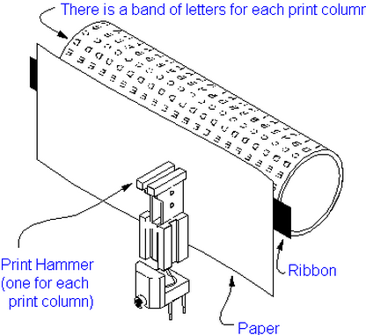

**Drum Printer**

* This number typically ranges from 80-132 print positions. The drum rotates at a rapid speed. For each possible print position there is a print hammer located behind the paper. These hammers strike the paper, along the ink ribbon, against the proper character on the drum as it passes.
* One revolution of the drum is required to print each line. This means that all characters on the line are not printed at exactly the same time, but the time required to print the entire line is fast enough to call them line printers.
* Typical speeds of drum printers are in the range of 300 to 2000 lines per minute.

**Chain Printer:-**

* A chain printer uses a chain of print characters wrapped around two pulleys. Like the drum printer, there is one hammer for each print position.

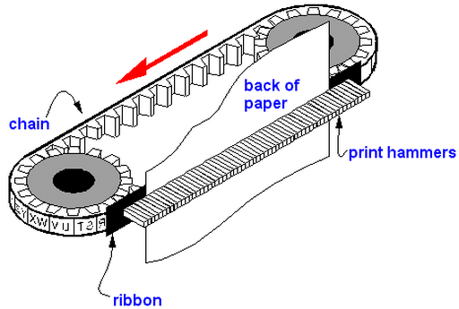

**Chain Printer**

* Circuitry inside the printer detects when the correct character appears at the desired print location on the page.
* The hammer then strikes the page, pressing the paper against a ribbon and the character located at the desired print position. An impression of the character is left on the page.
* The chain keeps rotating until all the required print positions on the line have filled. T
* When the page moves up to print the next line. Speeds of chain printers range from 400 to 2500 characters per minute.

**Band Printer:-**

* A band printer operates similar to chain printer except it uses a band instead of a chain and has fewer hammers. Band printer has a steel band divided into five sections of 48 characters each.

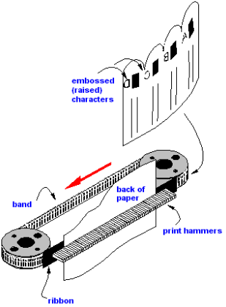

**Band Printer**

* The hammers on a band printer are mounted on a cartridge that moves across the paper to the appropriate positions. Characters are rotated into place and struck by the hammers. Font styles can easily be changed by replacing a band or chain.